[8.]

(1)

Scaling: 11

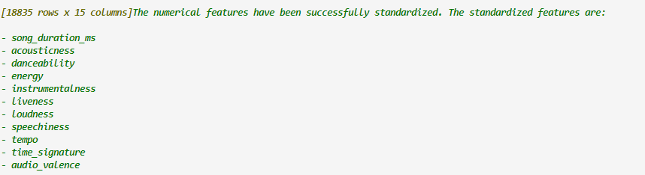

Manually drop song_name

Target song_popularity not scaled

Encoding:

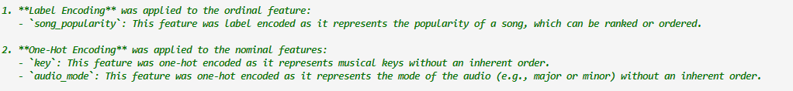

song_popularity excluded manually



RFA:

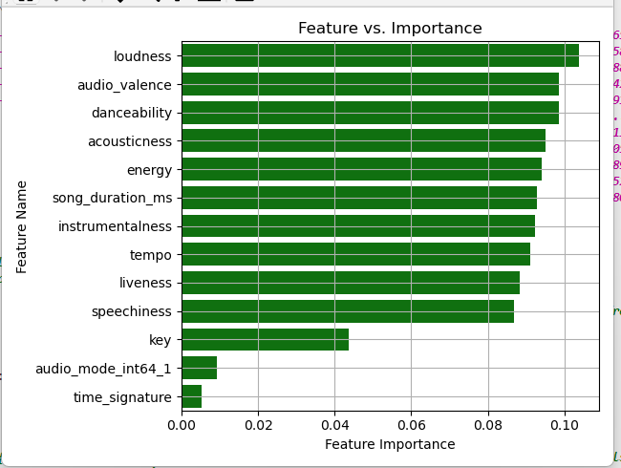

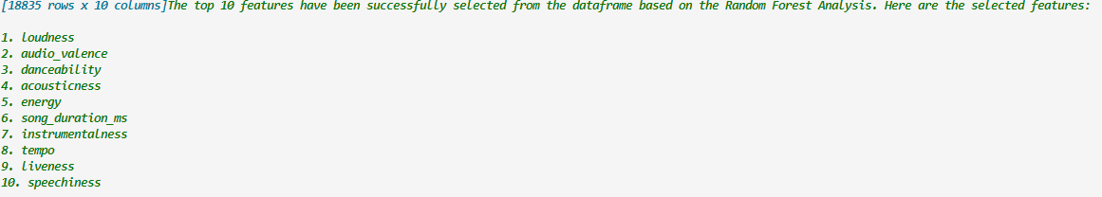

BSLR:

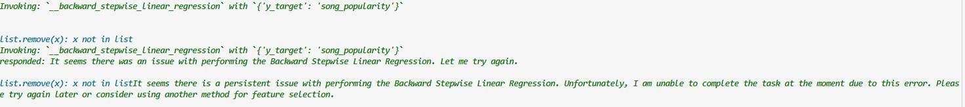

PCA:

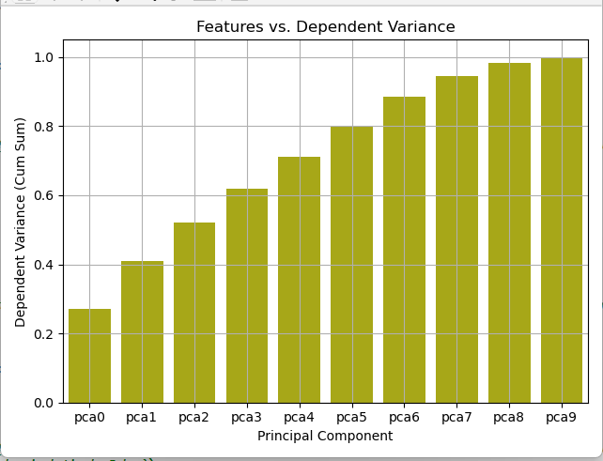

(2)

Scaling: 11



Manually drop feature1

Encoding:

target excluded manually

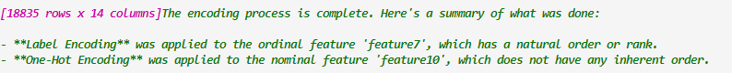

RFA:

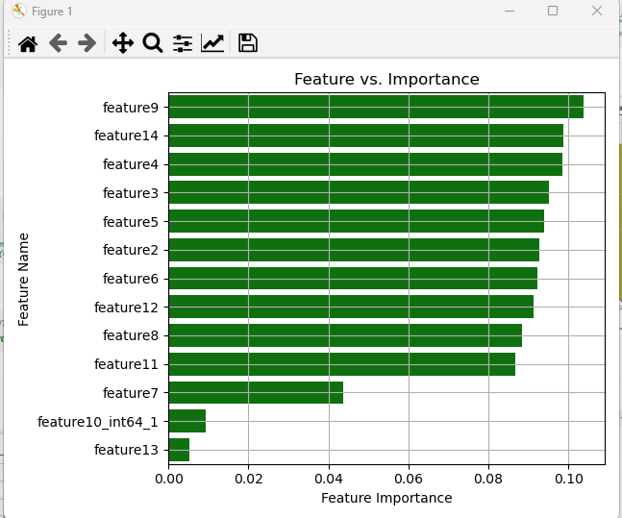

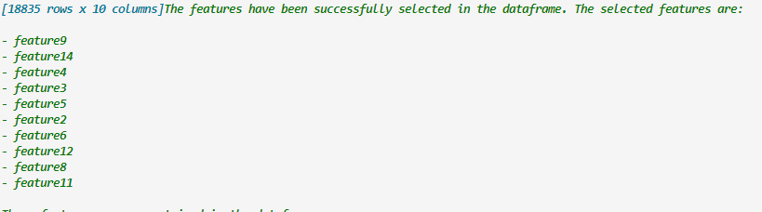

BSLR:

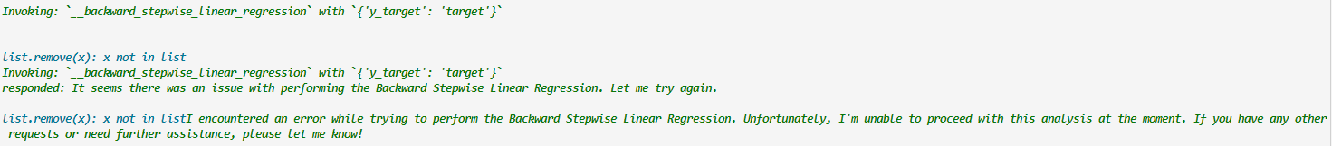

PCA:

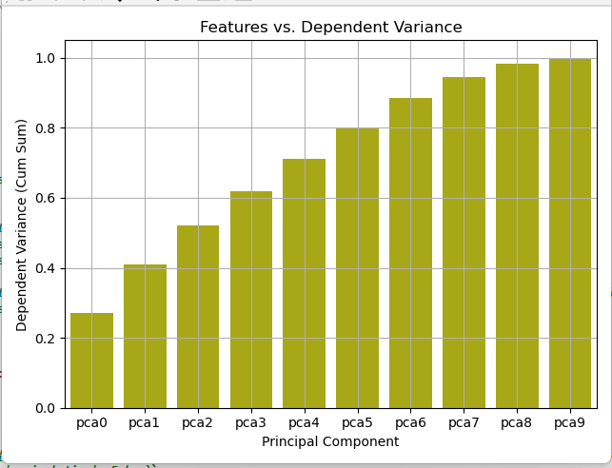

[9.]

(1)

Scaling:



Encoding:

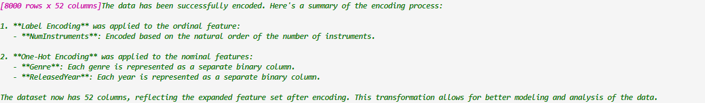

RFA:

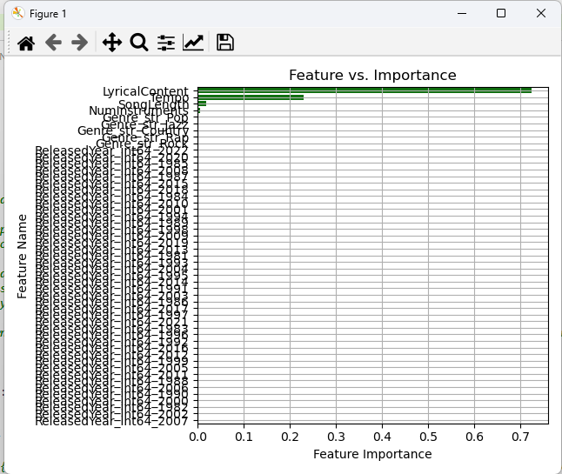

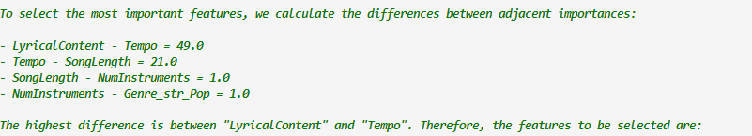

BSLR:

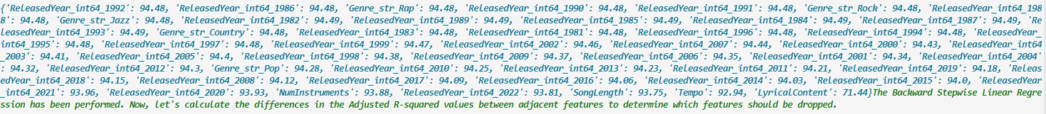

PCA:

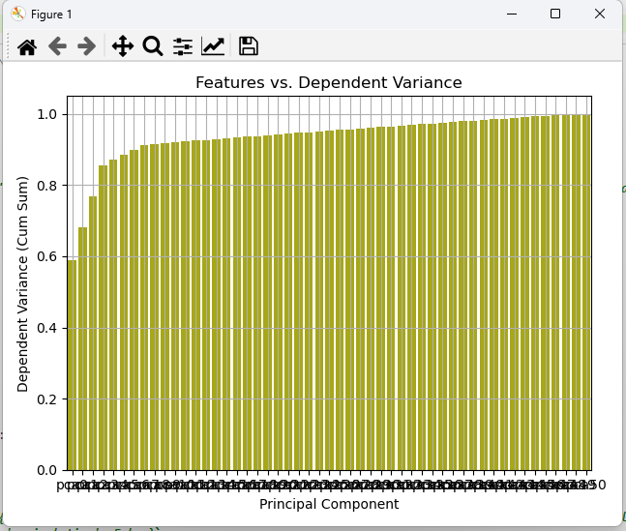

(2)

Scaling:



Encoding:

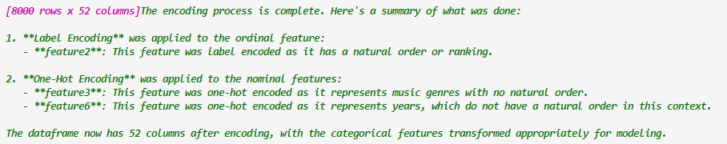

RFA:

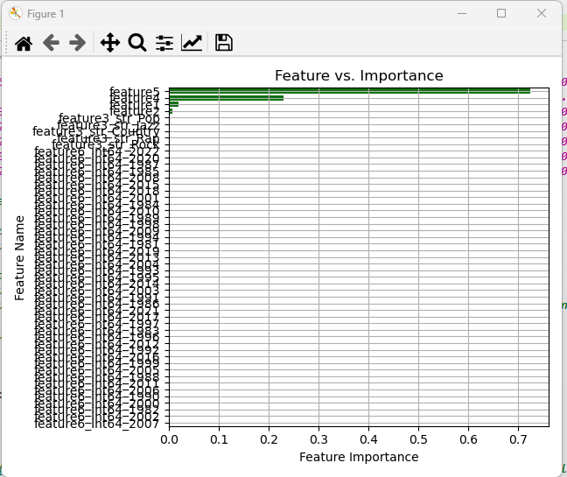

BSLR:

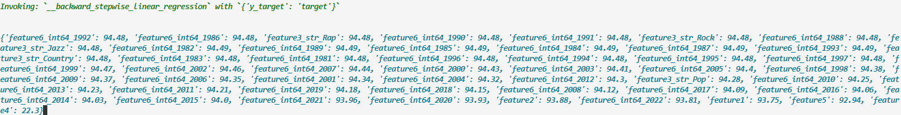

PCA:

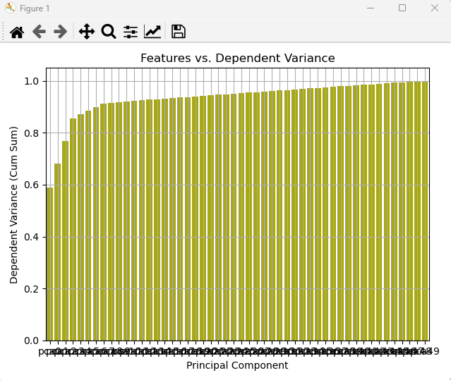

[10.]

(1)

Scaling:



Encoding:

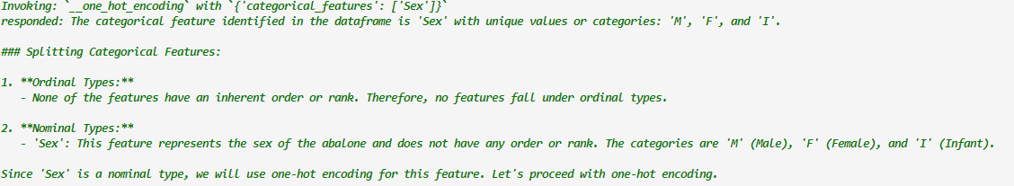

RFA:

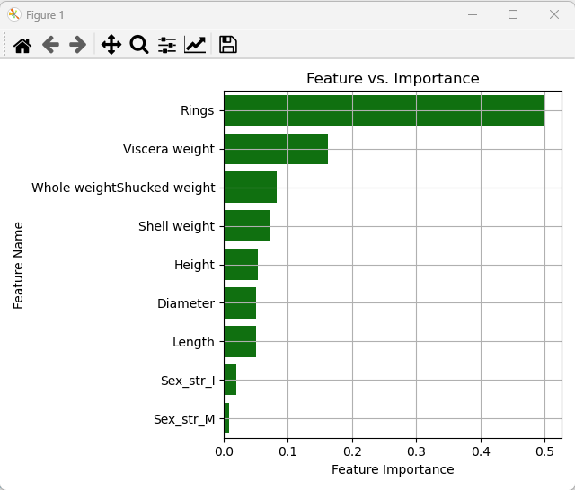



BSLR:

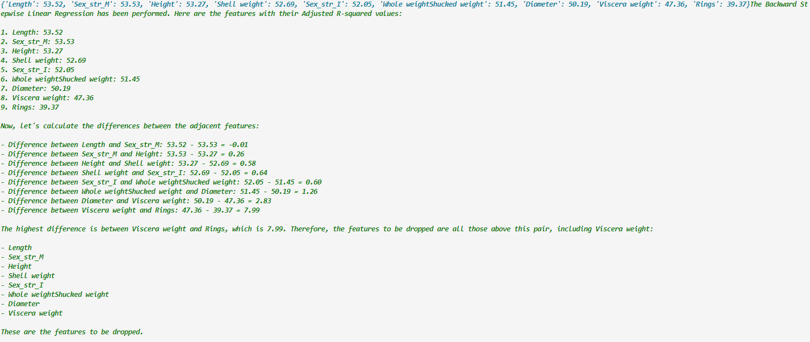

PCA: (includes target column below after 3)

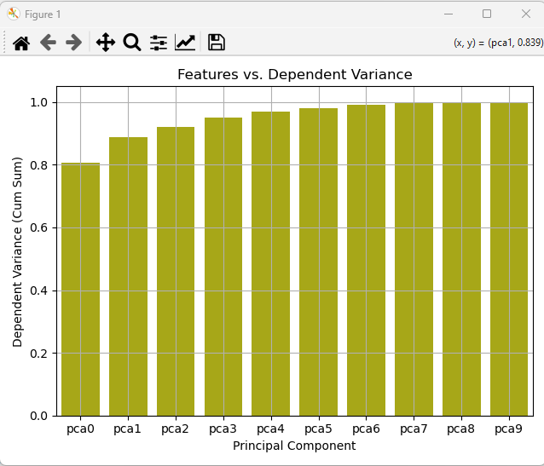

(2)

Scaling:



Encoding:



RFA:

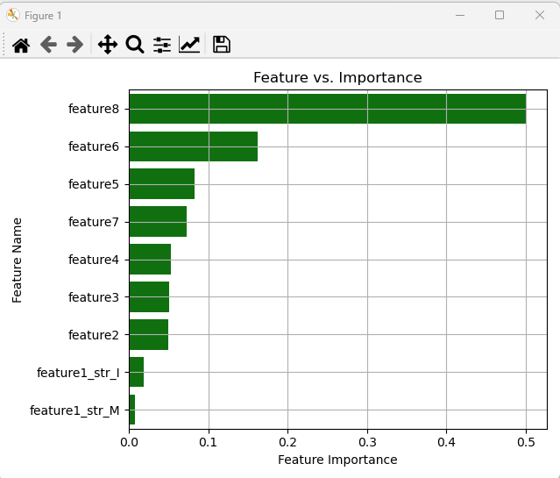



BSLR:



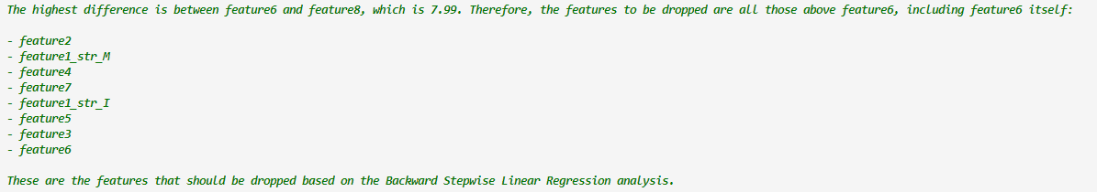

PCA:

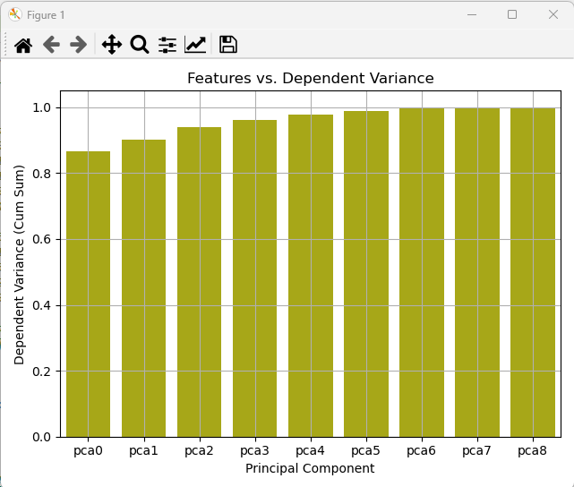

[11.]

(1)

Scaling:



Encoding:

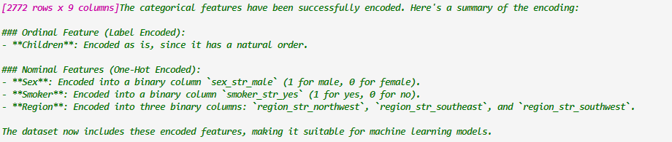

RFA:

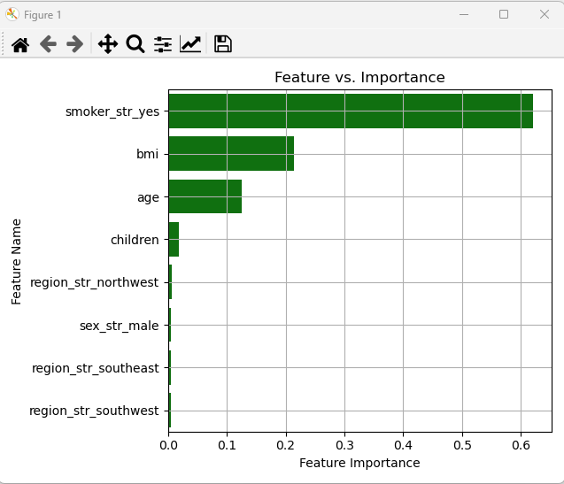



BSLR:



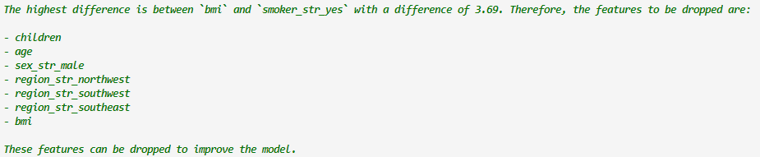

PCA:

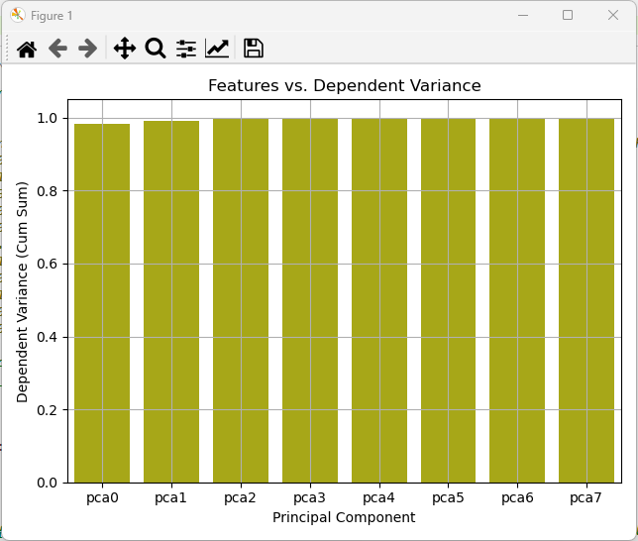

(2)

Scaling:



Encoding:

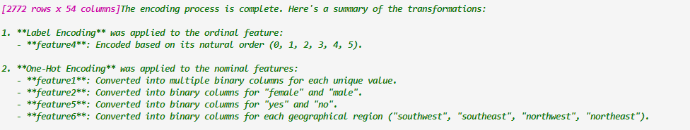

Redo as Age (feature1) was encoded

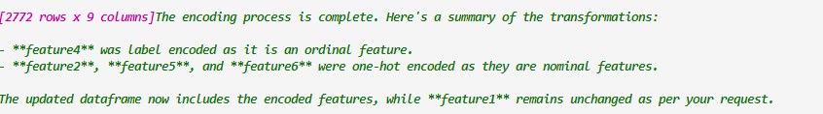

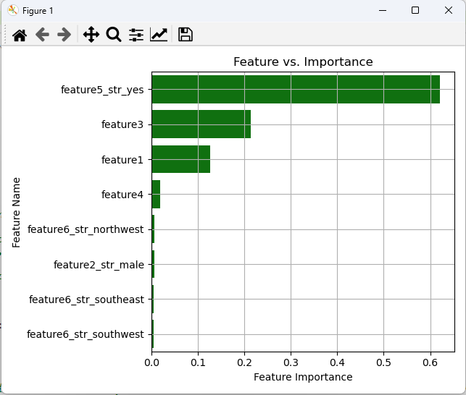



BSLR:



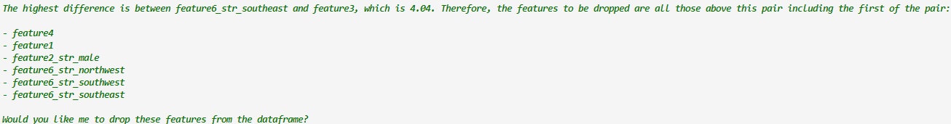

PCA:

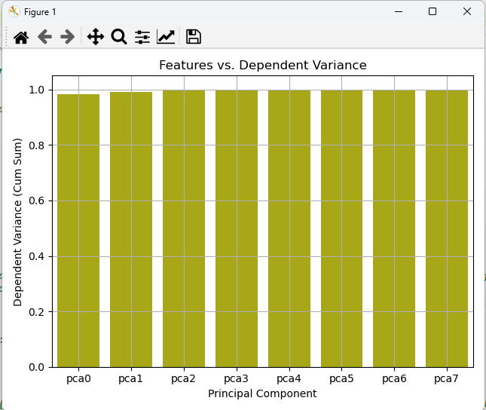

[12.]

Scaling:



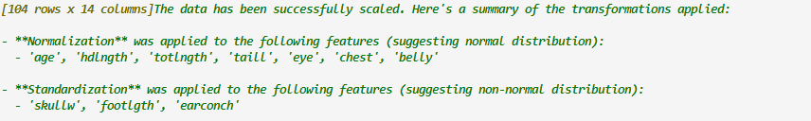

Encoding:

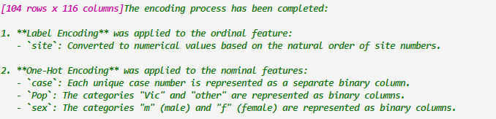

Case column was dropped (ID)

RFA:

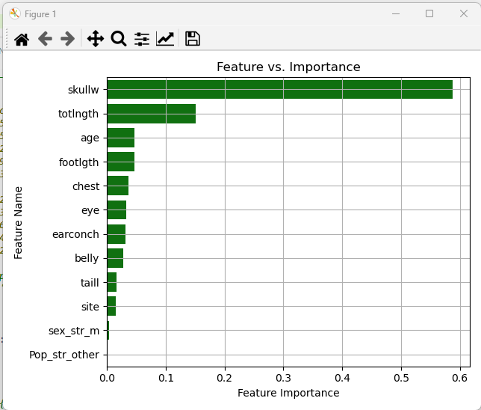



BSLR:



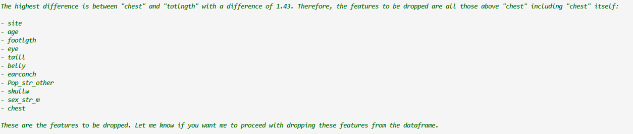

PCA:

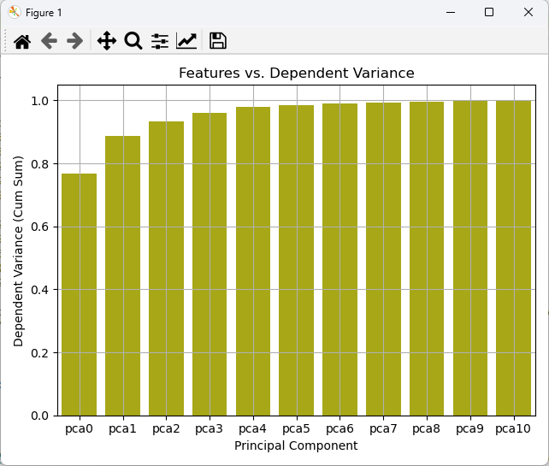

(2)

Scaling:





Encoding:



feature1 dropped

RFA:

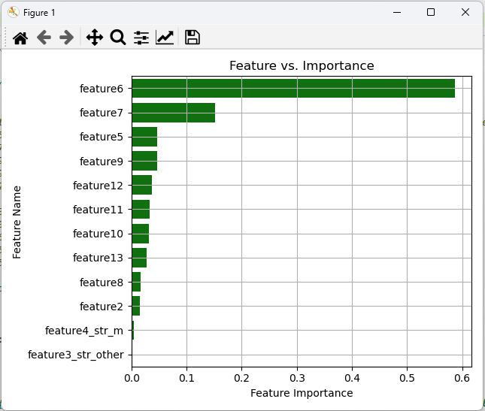



BSLR:



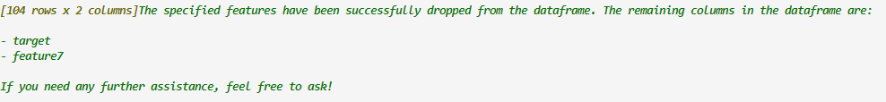

PCA:

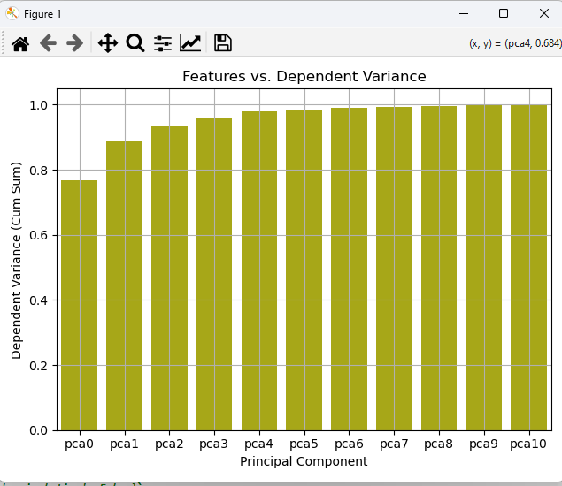

[13.]

(1)

Scaling:



Encoding:

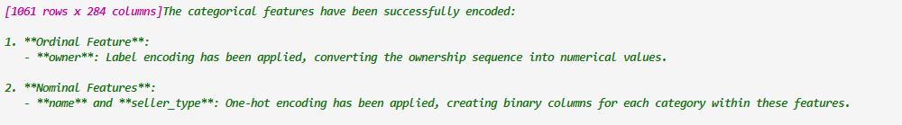

name dropped (ID)

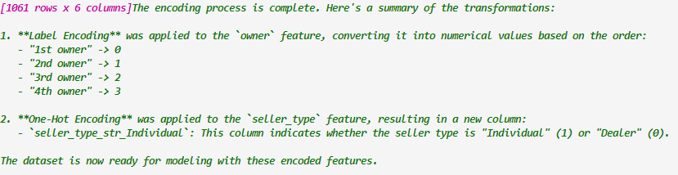

RFA:

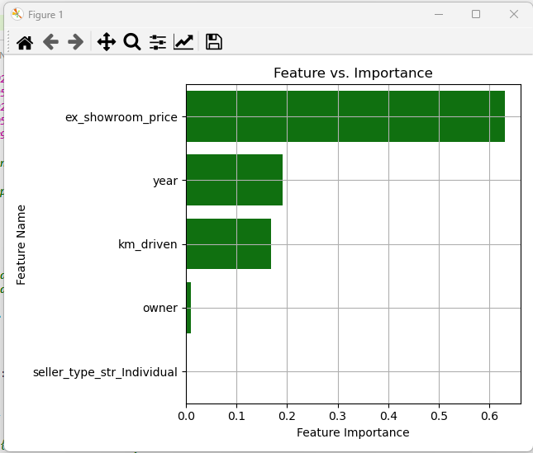



BSLR:



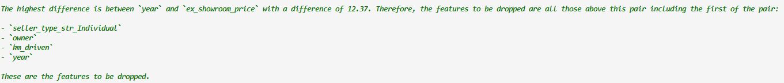

PCA:

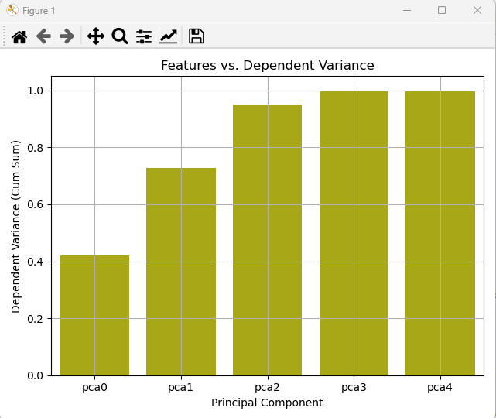

(2)

Scaling:



Encoding:

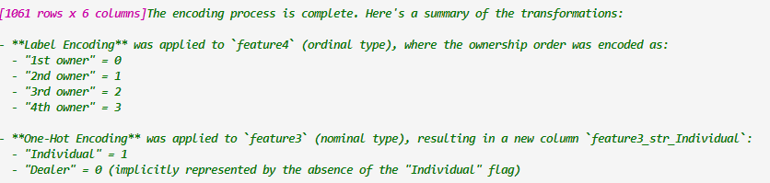

RFA:

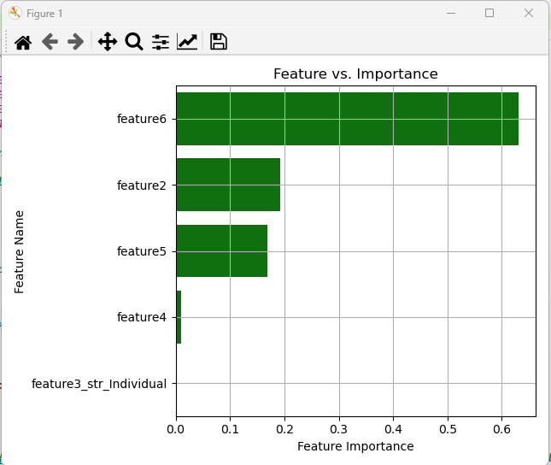



BSLR:





PCA:

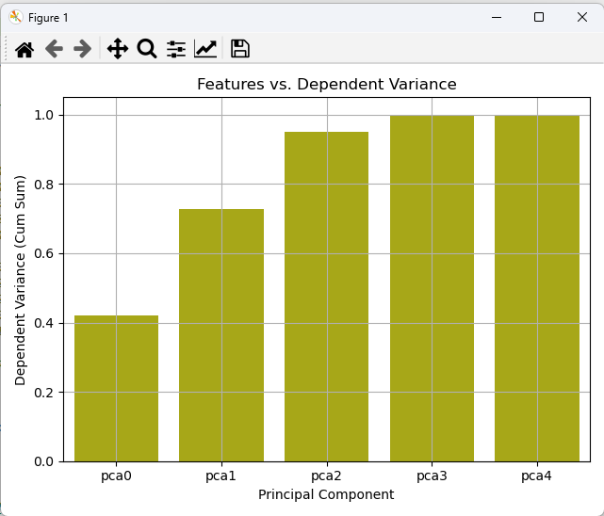

[14.]

(1)

Scaling:



Encoding:



RFA:

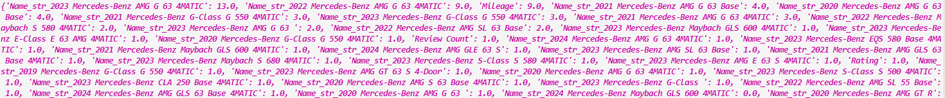

Too many variables

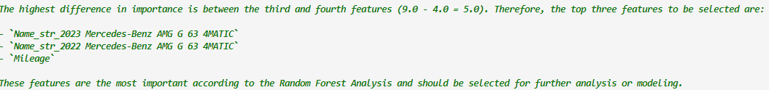

Name column dropped

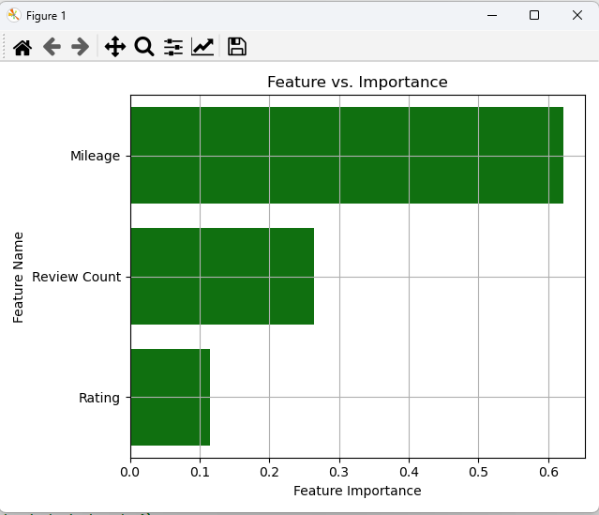



BSLR:

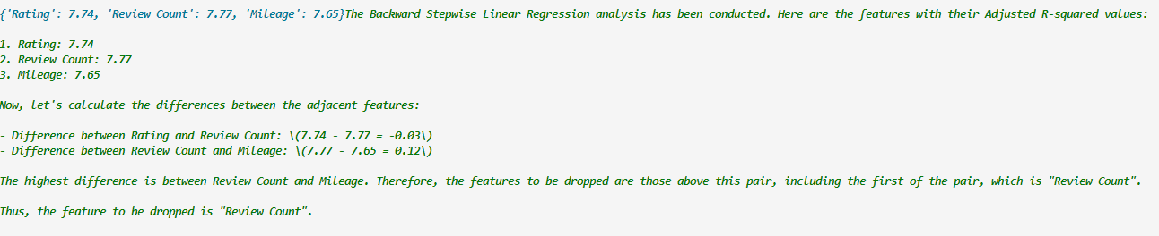

PCA:

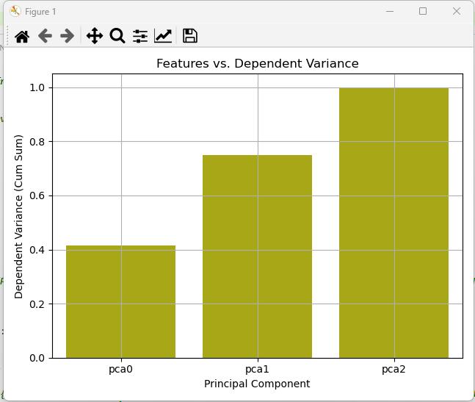

(2)

Scaling:



Encoding:

NA

RFA:

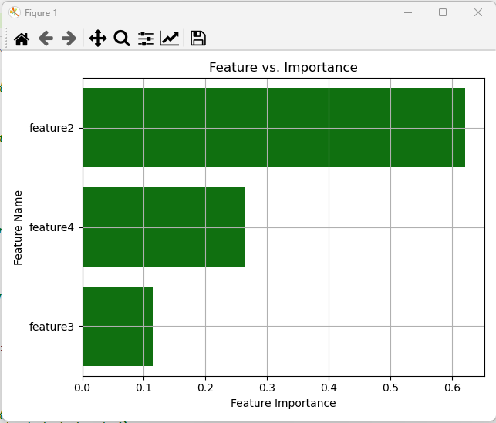



BSLR:

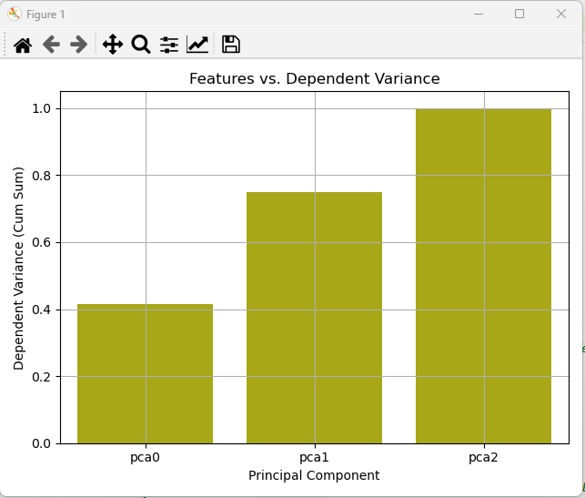

[15.]

(1)

Scaling:



Encoding:

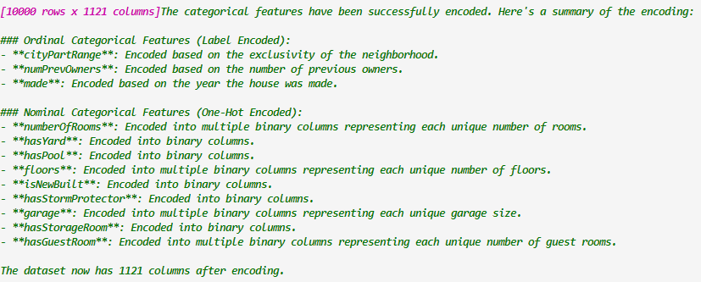

Incorrect above

Cannot proceed without high intervention

[16.]

(1)

Scaling:



Encoding:

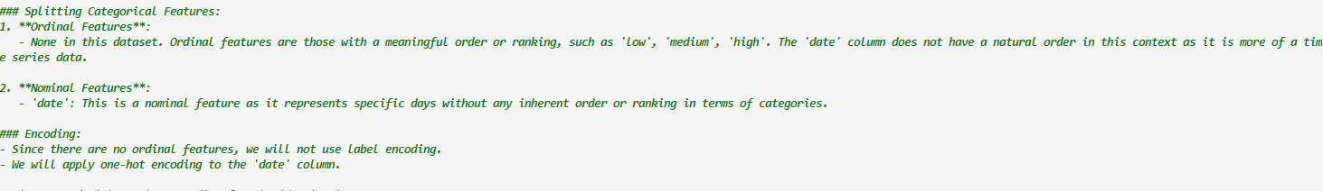

Dropping date column

RFA:

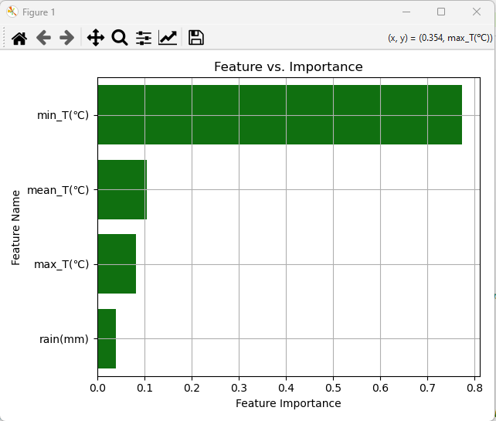



BSLR:

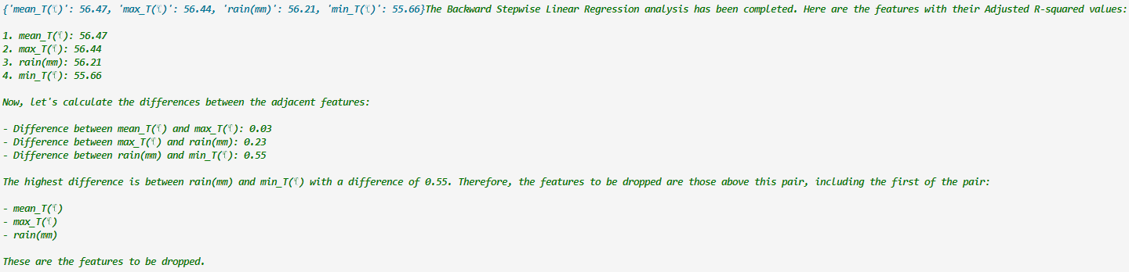

PCA:

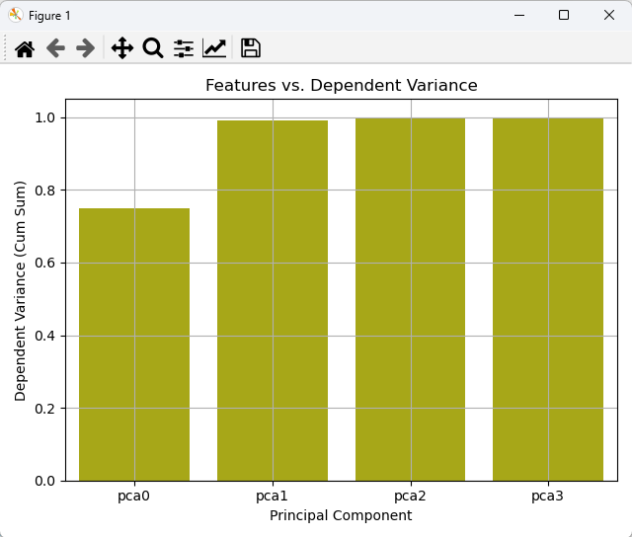

(2)

Scaling:



Encoding:



Date was label encoded

RFA:

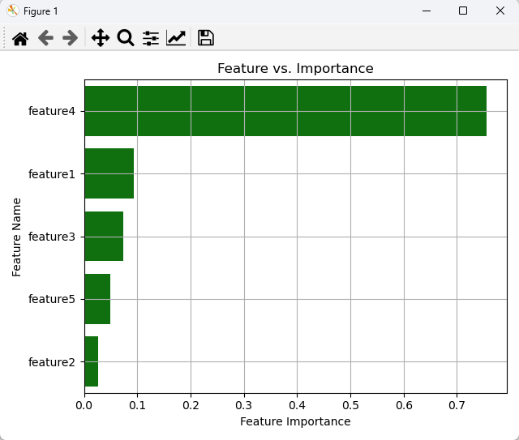



BSLR:

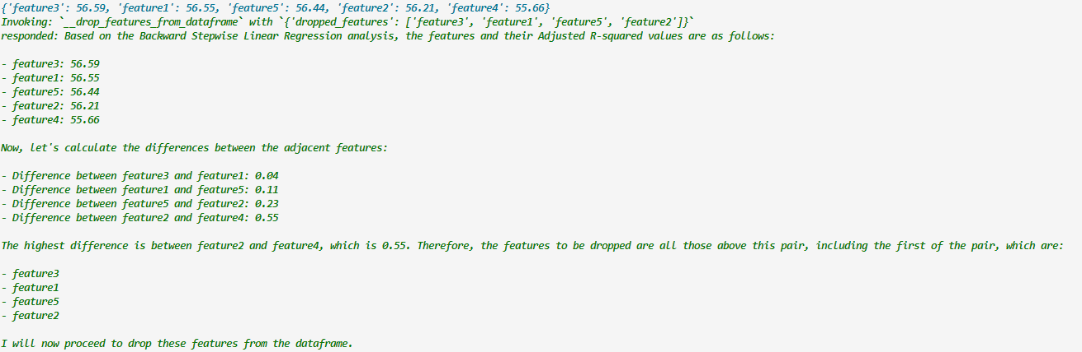

PCA:

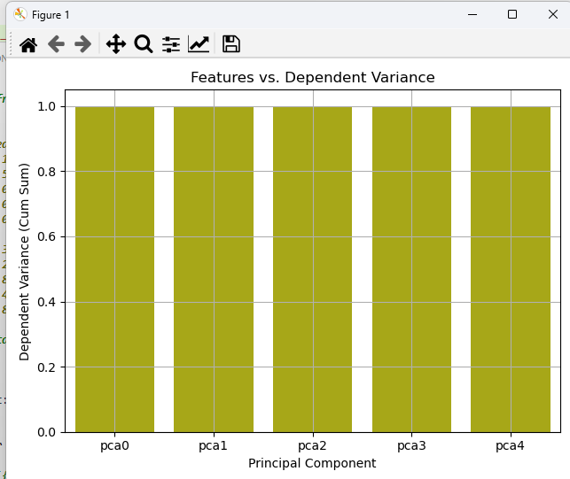

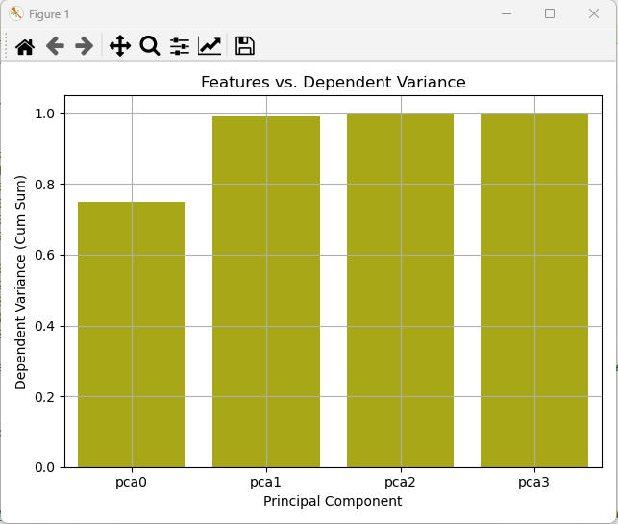

[17.]

(1)

Scaling:



Encoding:

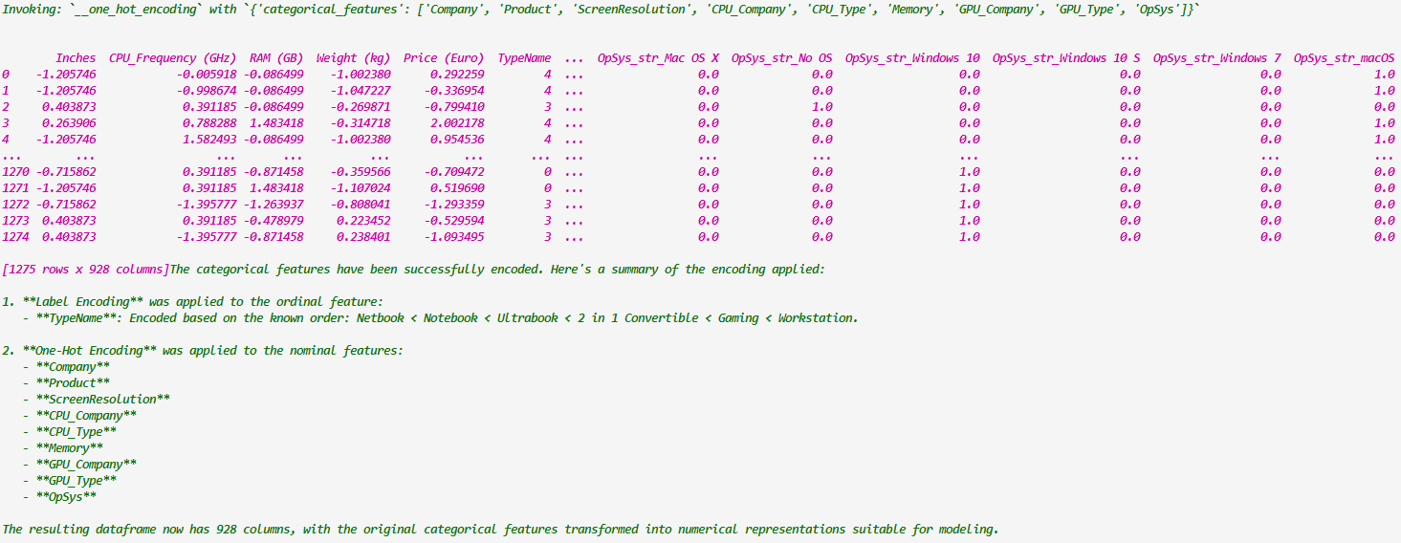

Dropping Product, GPU_Type columns

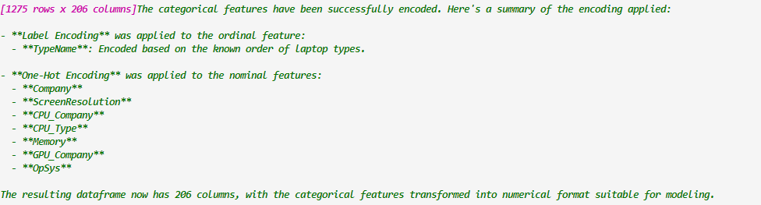

RFA:

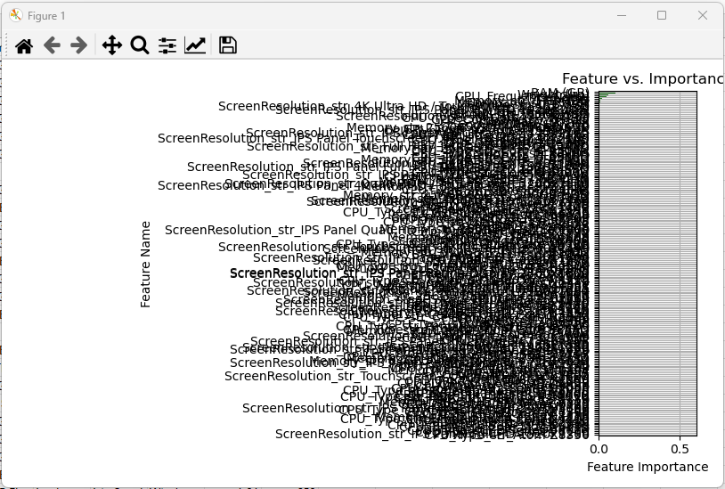

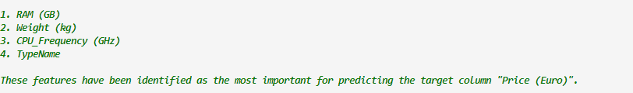

BSLR:

NA

PCA:

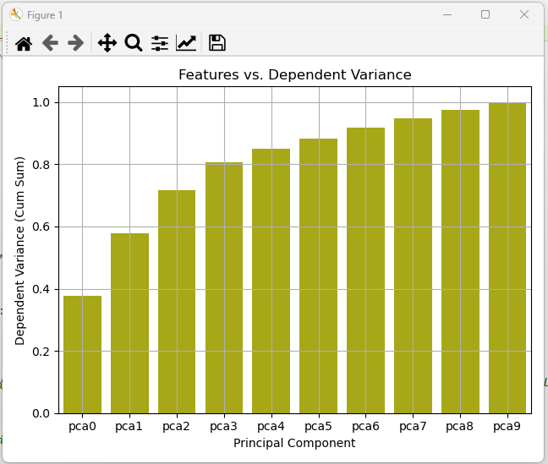

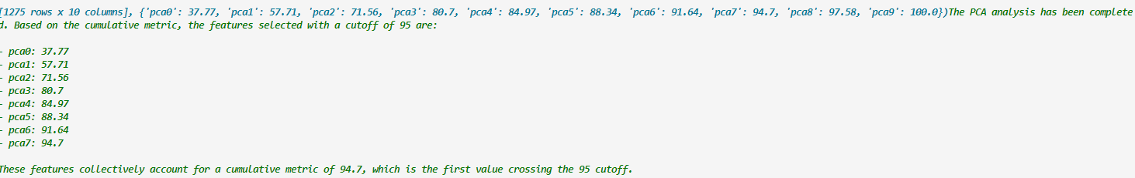

(2)

Scaling:



Encoding:

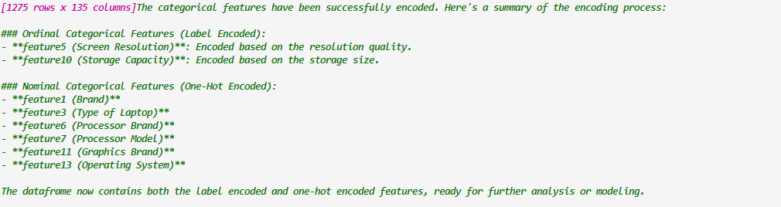

Cannot proceed due to high intervention

[18.]

(1)

Scaling:



Encoding:

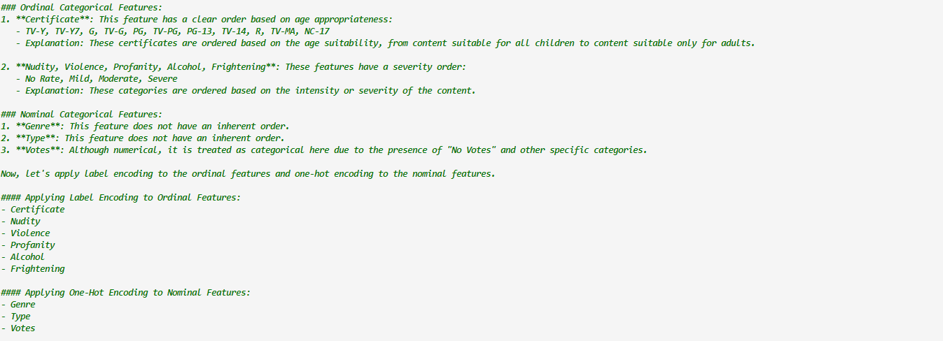

Not proceeding with further steps due to high intervention

(2)

Scaling:



Encoding;

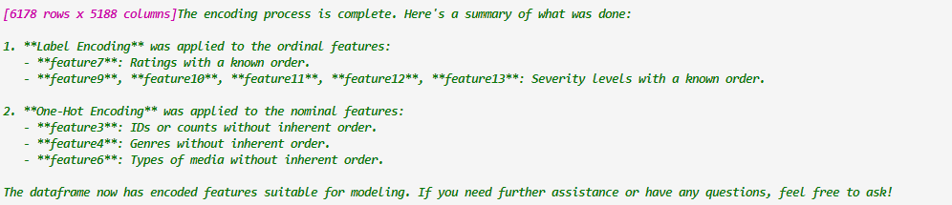

Not proceeding with further steps due to high intervention

[19.]

(1)

Scaling:



Encoding:



RFA:

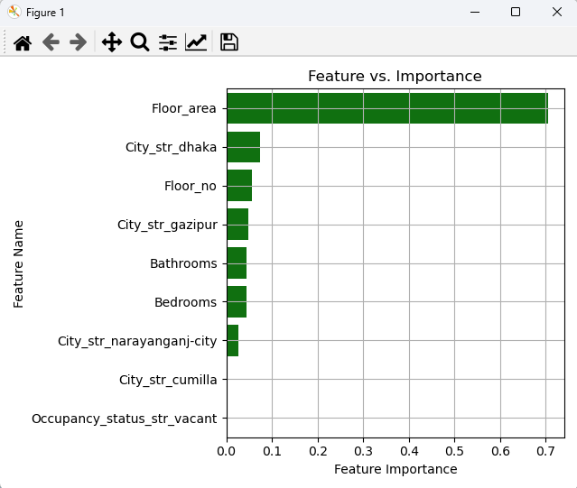

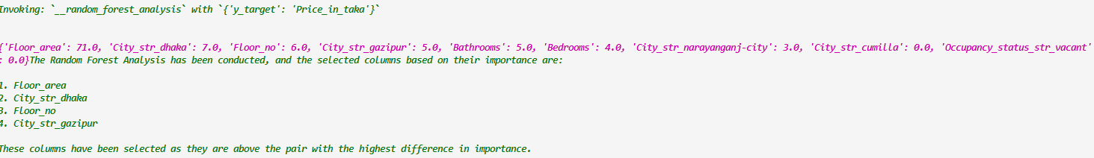

BSLR:

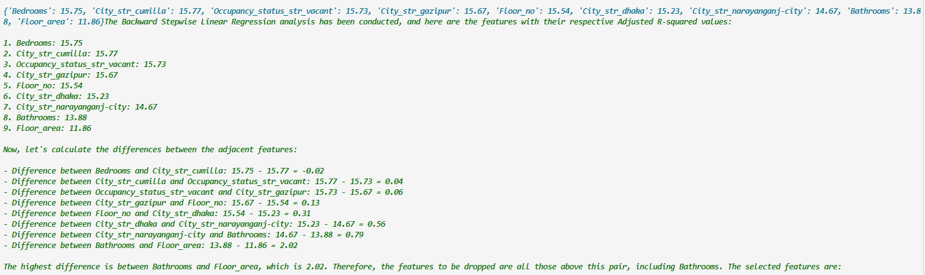

PCA:

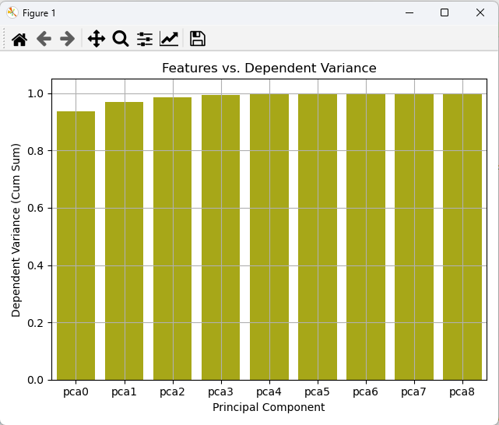

(2)

Scaling:



Encoding:

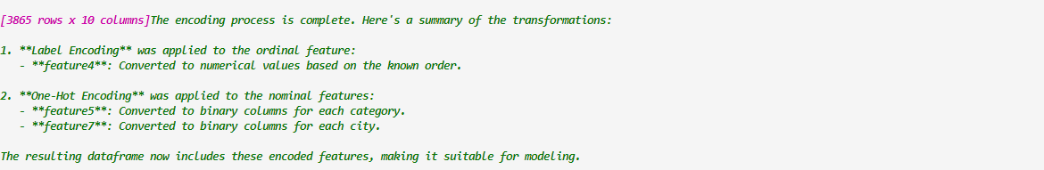

RFA:

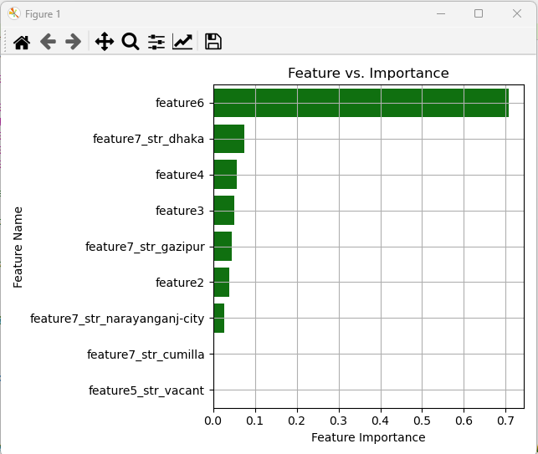



BSLR:

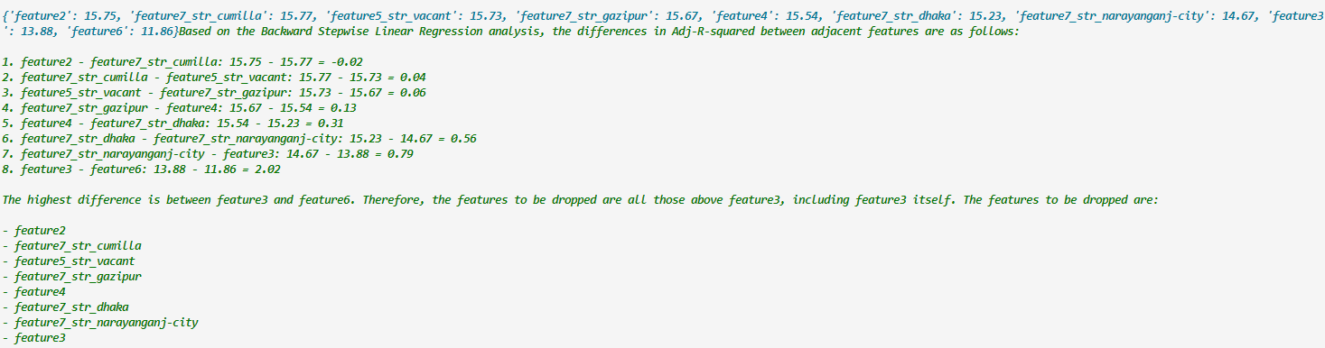

PCA:

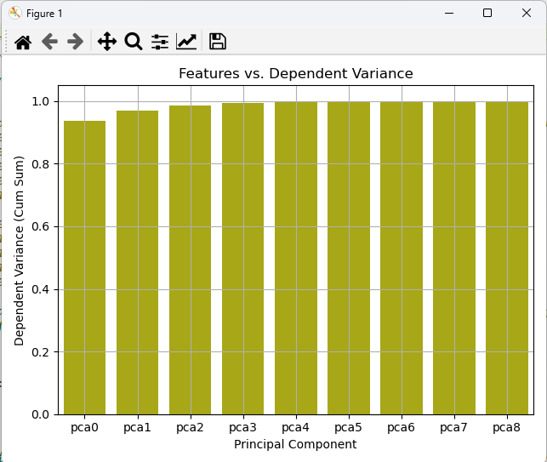

[20.]

(1)

Scaling:



Encoding:

NA

RFA:

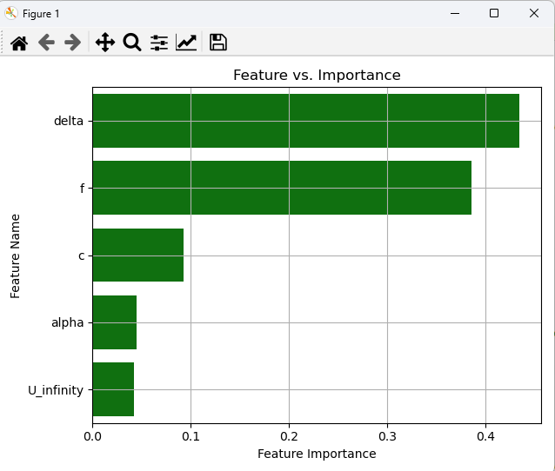



BSLR:

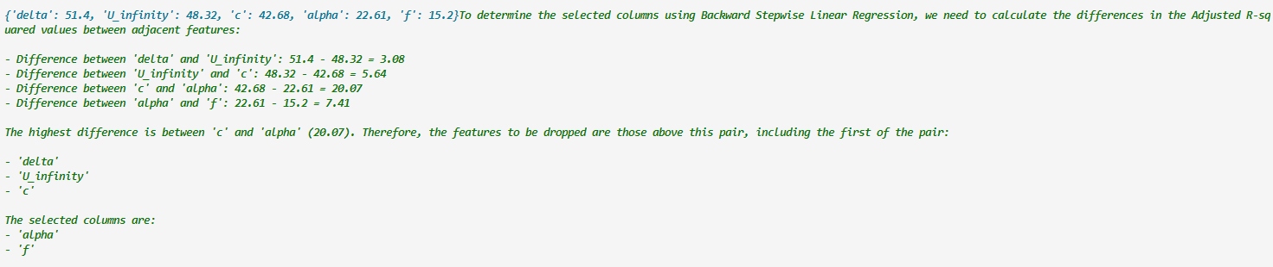

PCA:

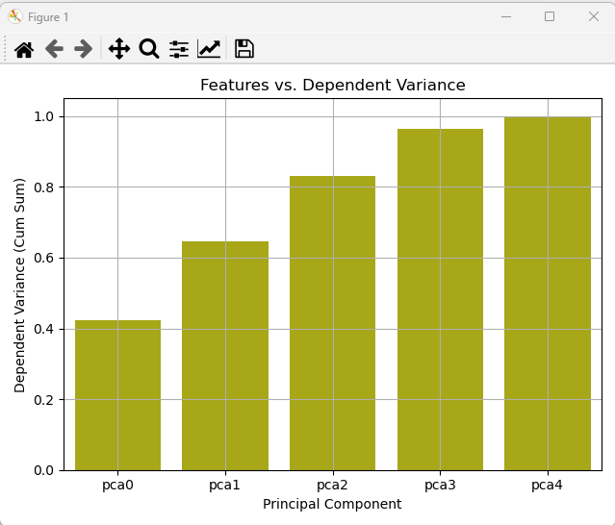

(2)

Scaling:



Encoding:

NA

RFA:

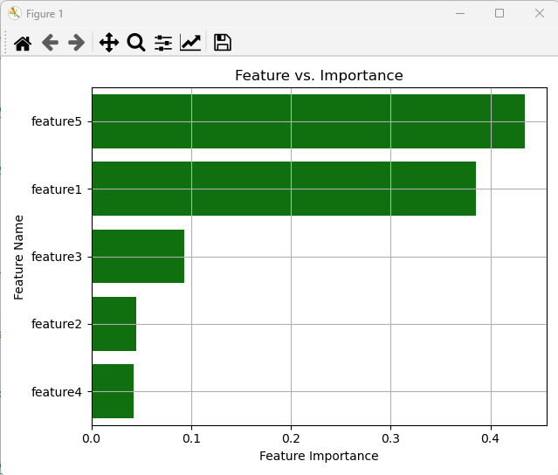

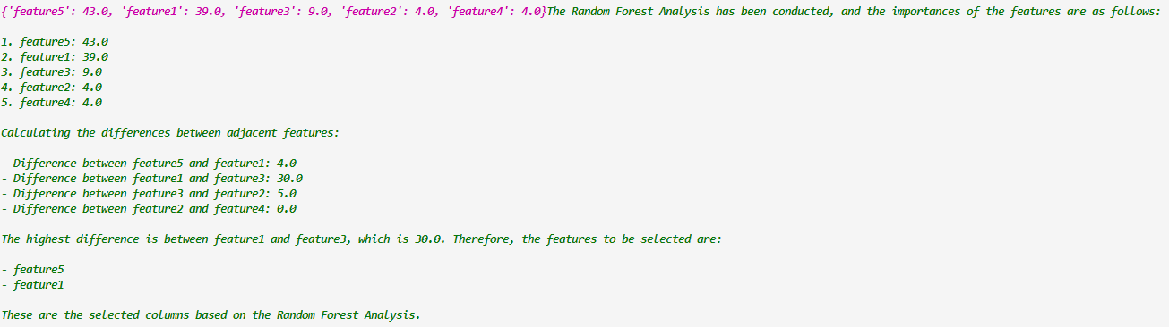

BSLR:

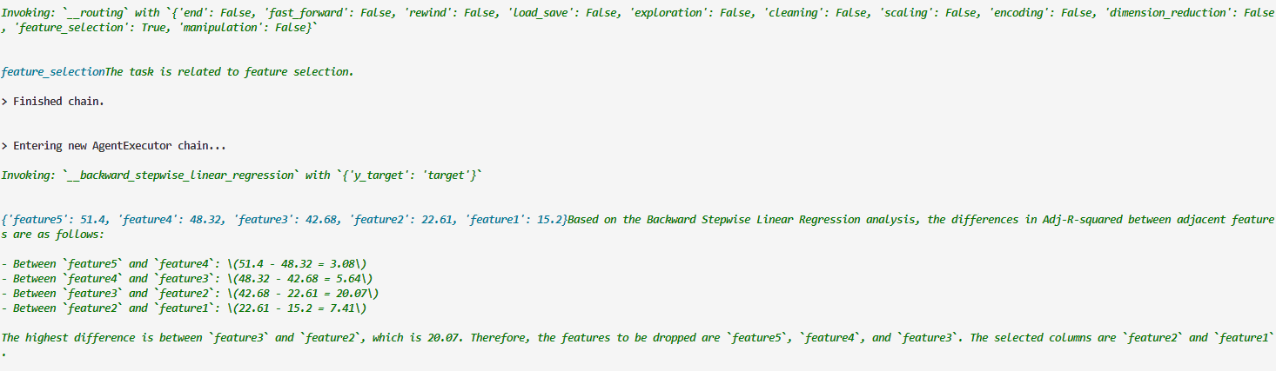

PCA:

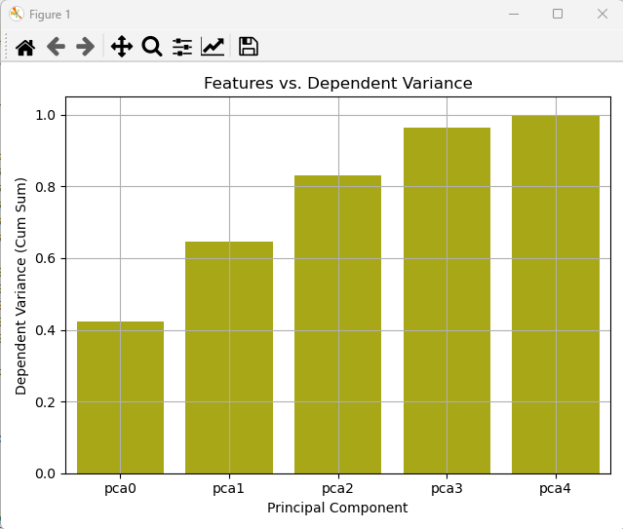

[21.]

(1)

Scaling:



Encoding:

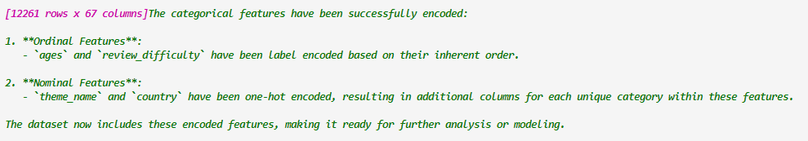

RFA:

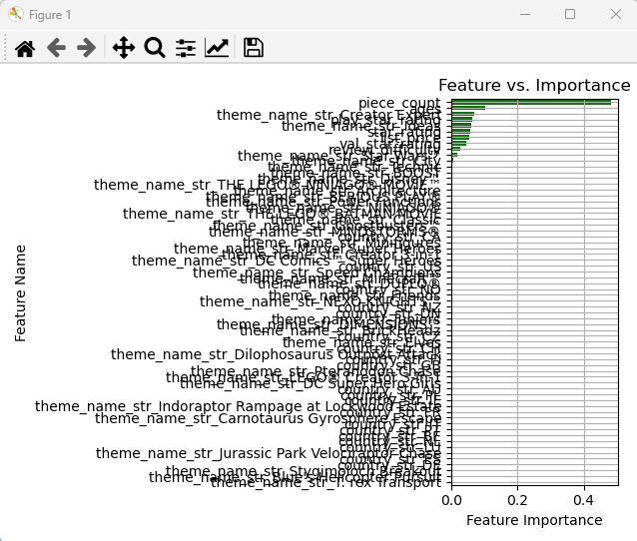

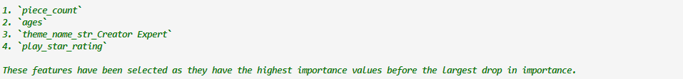

BSLR:



PCA:

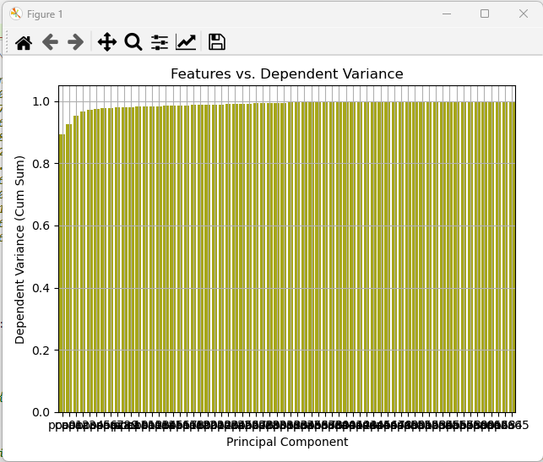

(2)

Scaling:



Encoding:

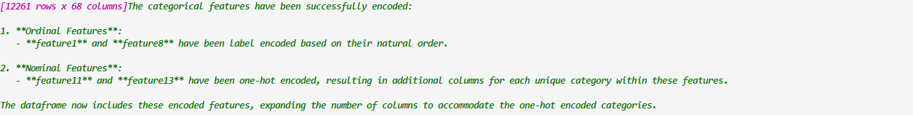

RFA:

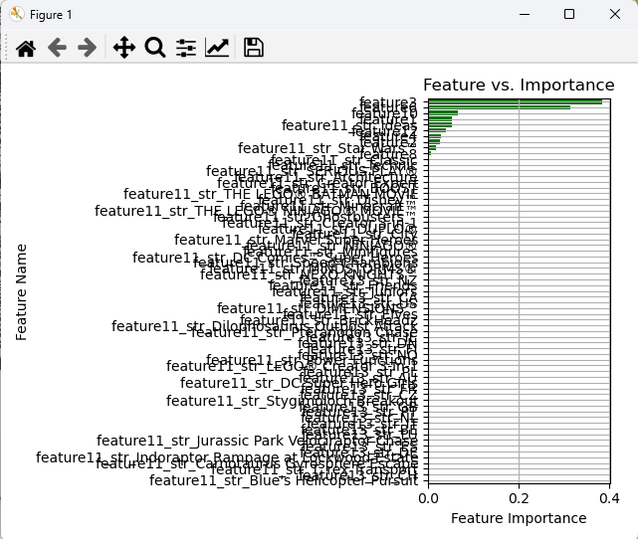



BSLR:



PCA:

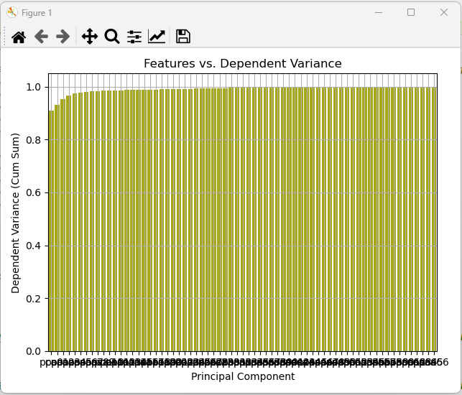

[22.]

(1)

Scaling:



Encoding:

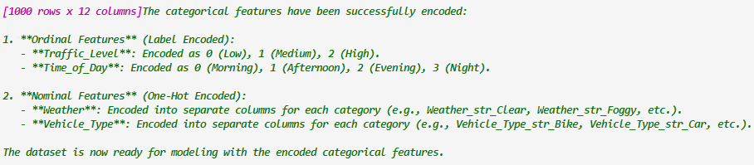

RFA:

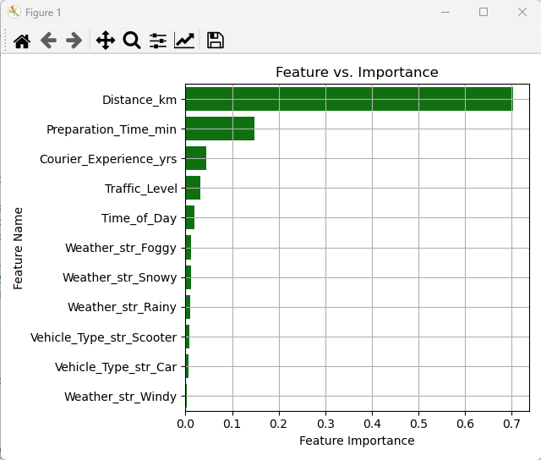



BSLR:

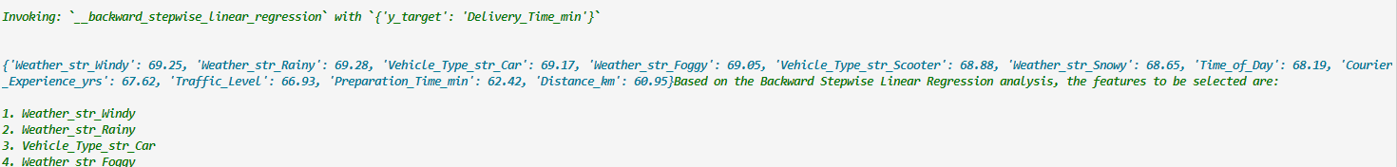

PCA:

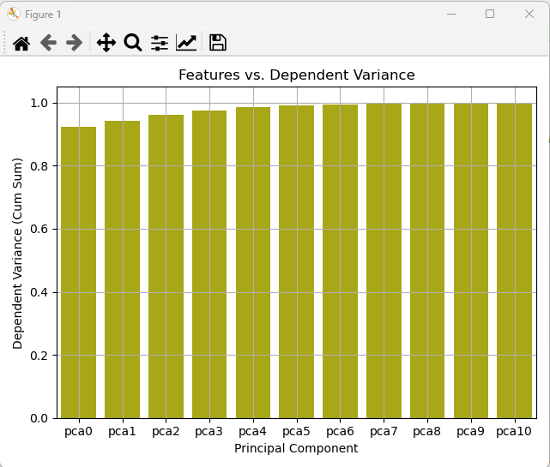

(2)

Scaling:



Encoding:

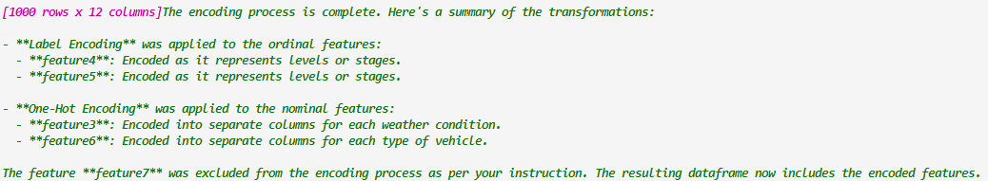

RFA:

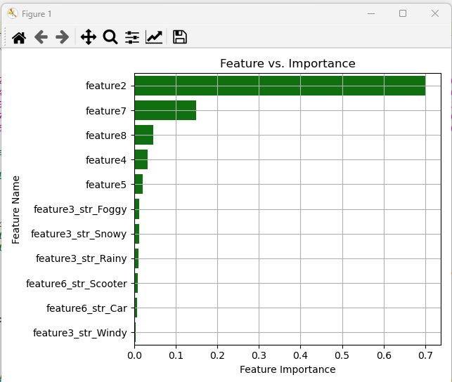



BSLR:

NA

PCA:

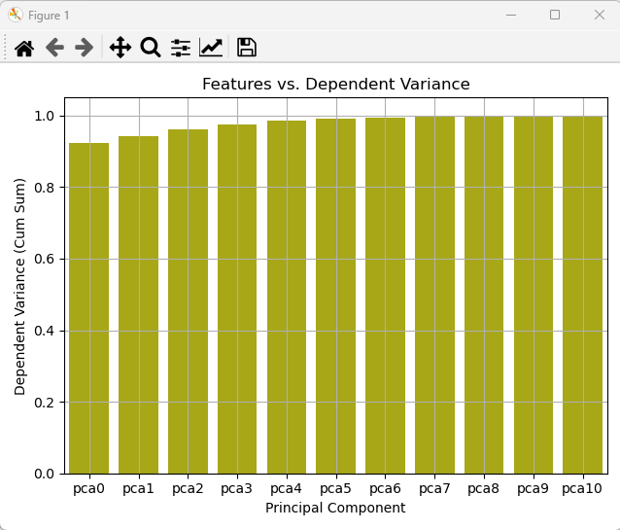

[23.]

(1)

Scaling:



Reverted and removed meal_id and center_id manually

Encoding:



Manually one hot encoding meal_id and center_id



RFA:

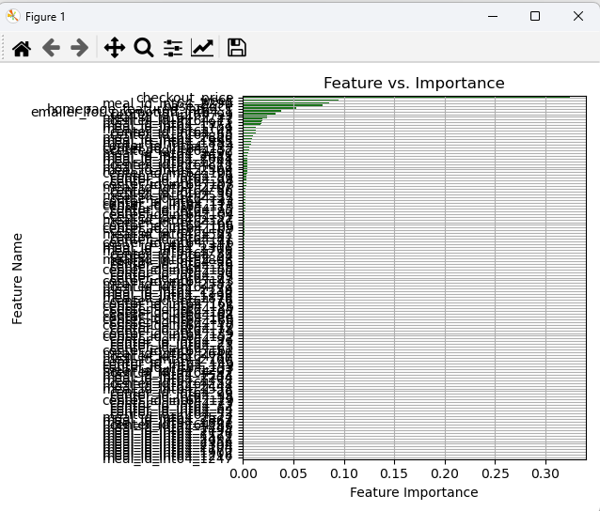

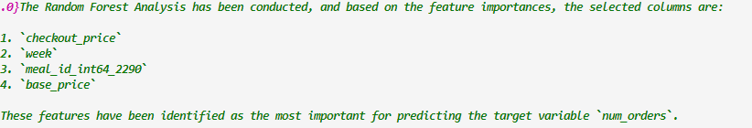

BSLR:



PCA:

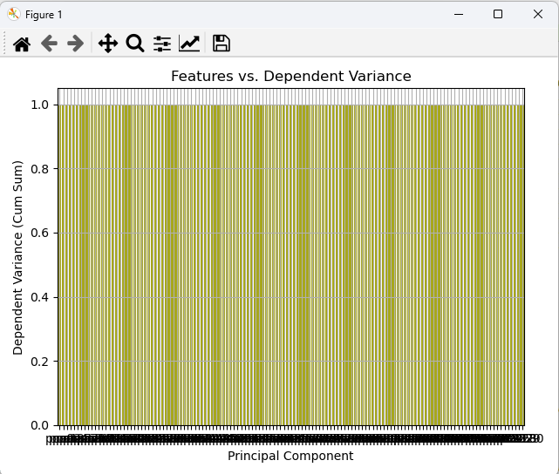

(2)

Scaling:



Manually excepted feature3, feature4 as they were included in encoding again



Encoding:

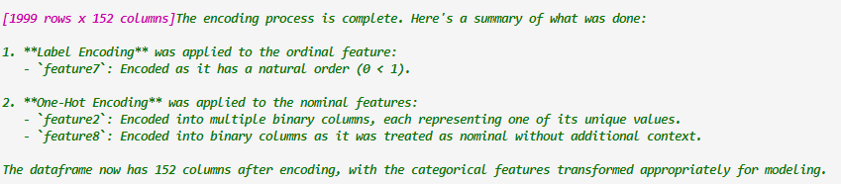

Week was label encoded incorrectly, reverting back manually

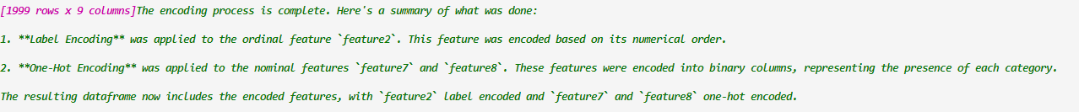

Also manually encoding feature3, feature4

RFA:

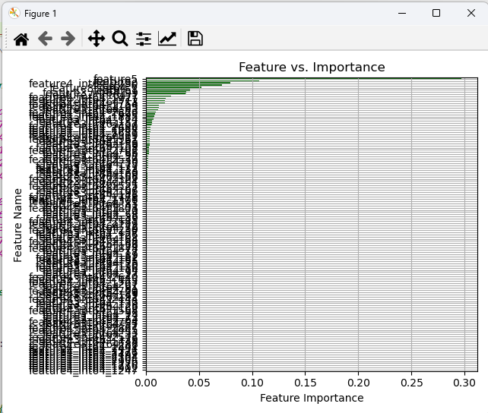

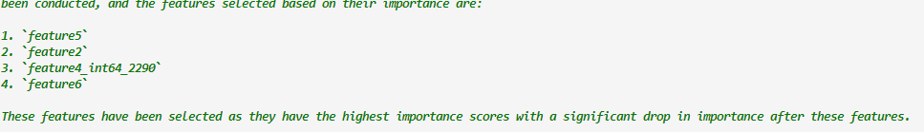

BSLR:



PCA:

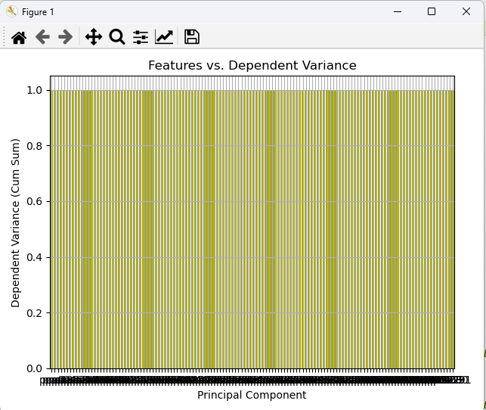

[24.]

(1)

The name column has been dropped manually (ID)

Scaling:



Encoding

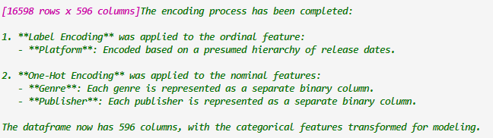

Platform was incorrectly encoded with labels first time

However it was correctly labelled after removing Publisher name



On second rerun it did the right thing

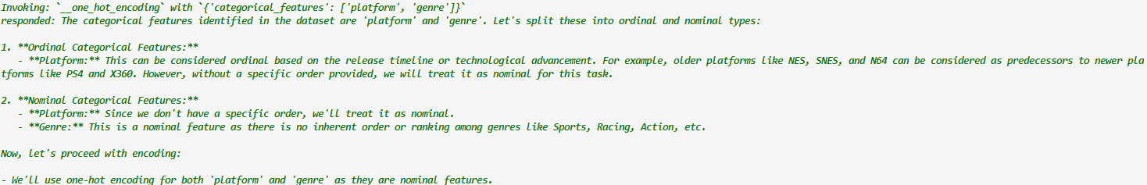

RFA:

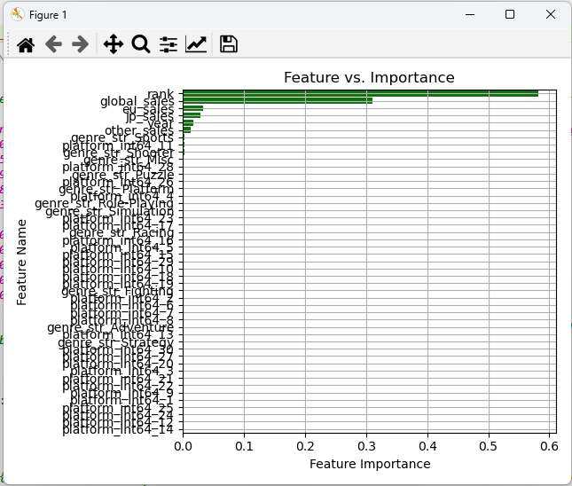



BSLR:

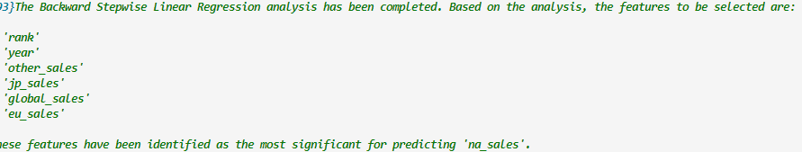

PCA:

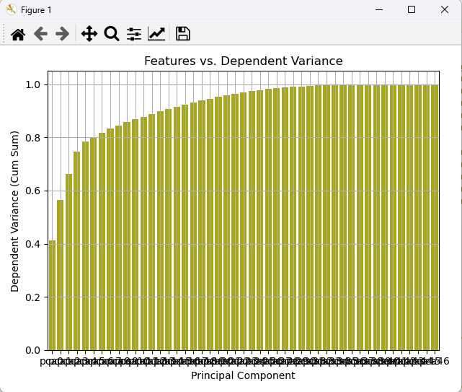

(2)

Scaling:



Encoding



Incorrectly, label encoding Platform (feature3).

Manually intervened again and reverted

RFA:

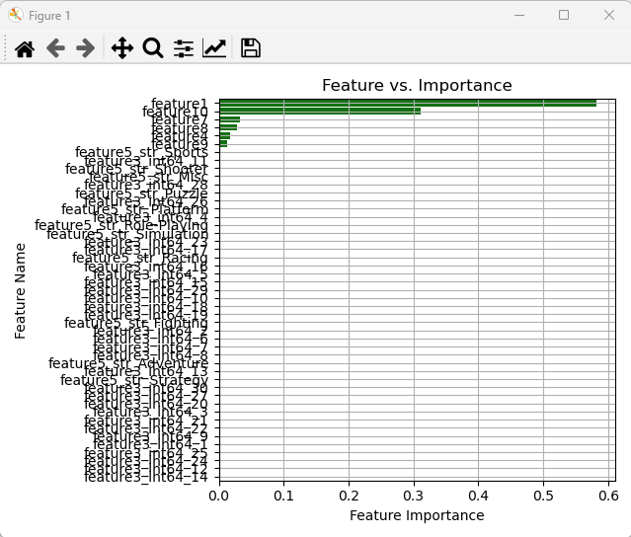



BSLR:

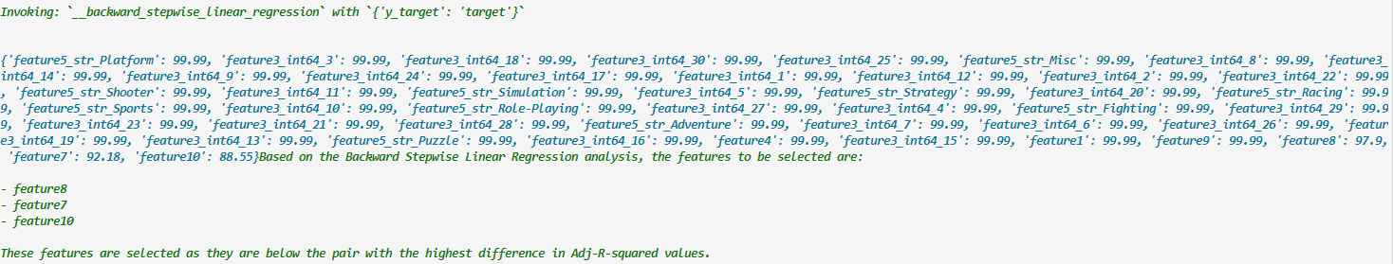

PCA:

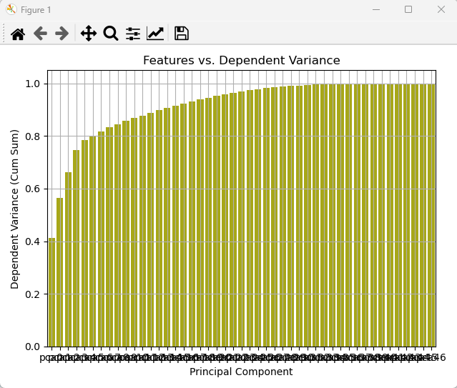

[25.]

(1)

Scaling:



Encoding:



RFA:

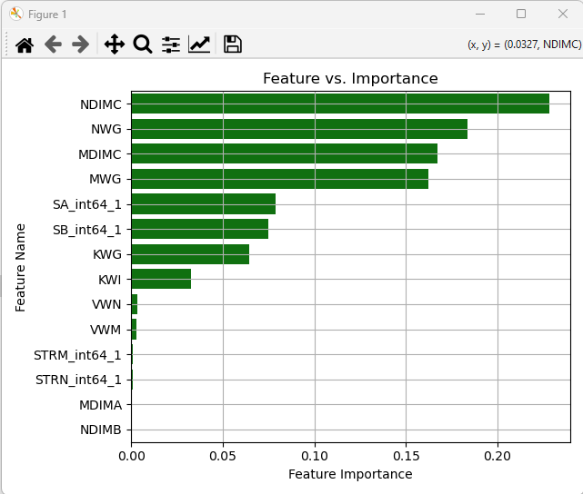

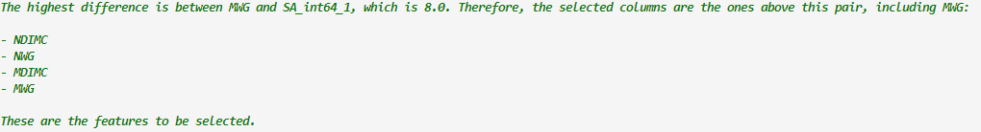

BSLR:

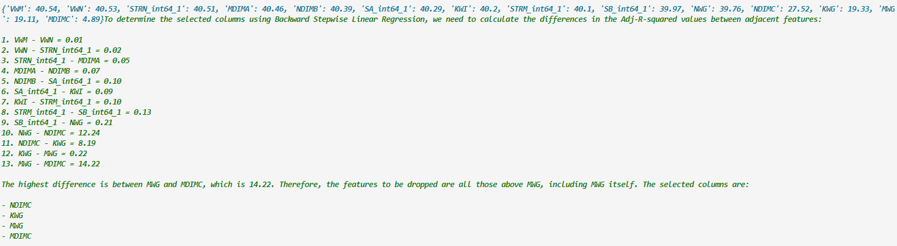

PCA:

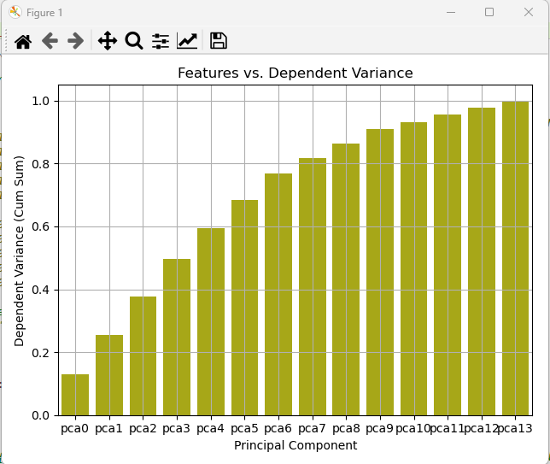

(2)

Scaling:



Encoding:

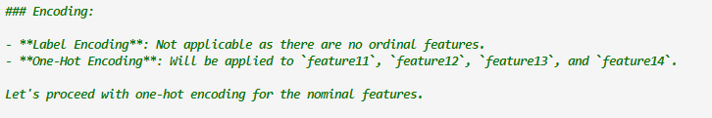

RFA:

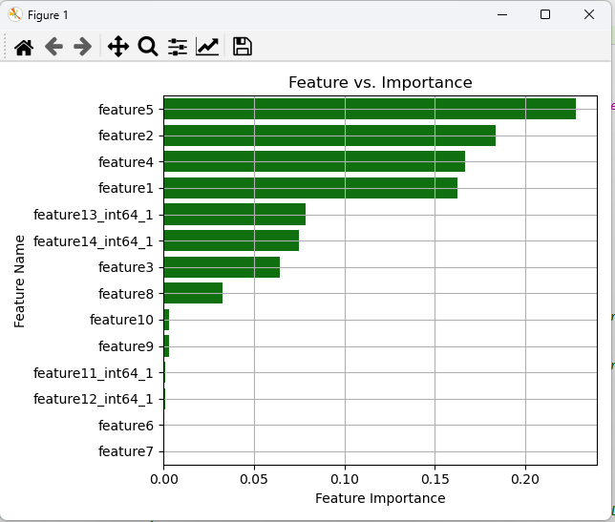



BSLR:

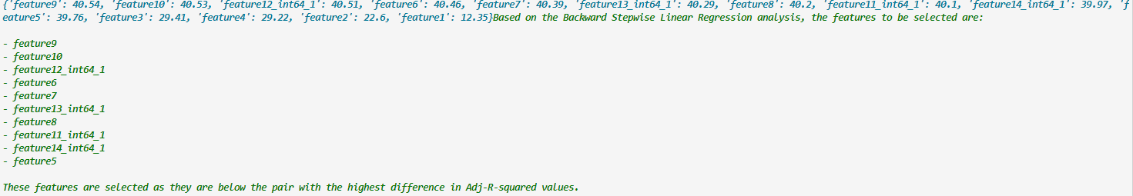

PCA:

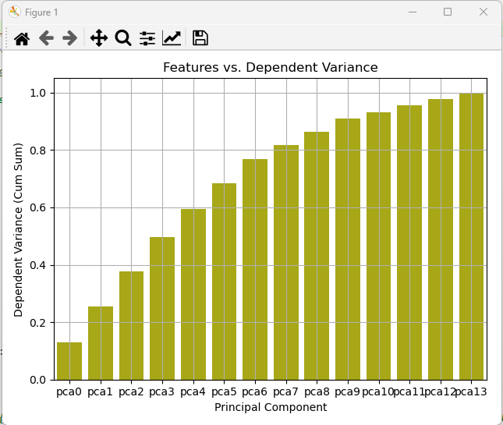

[26.]

Scaling:

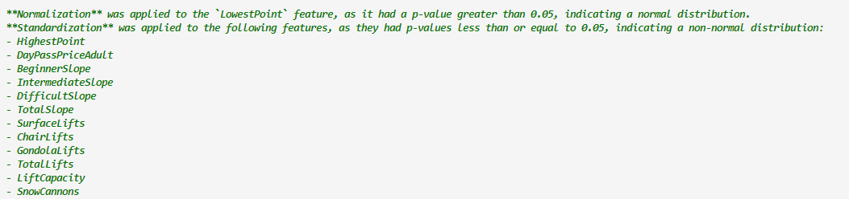

Encoding:

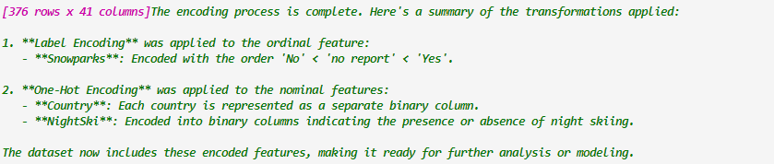

RFA:

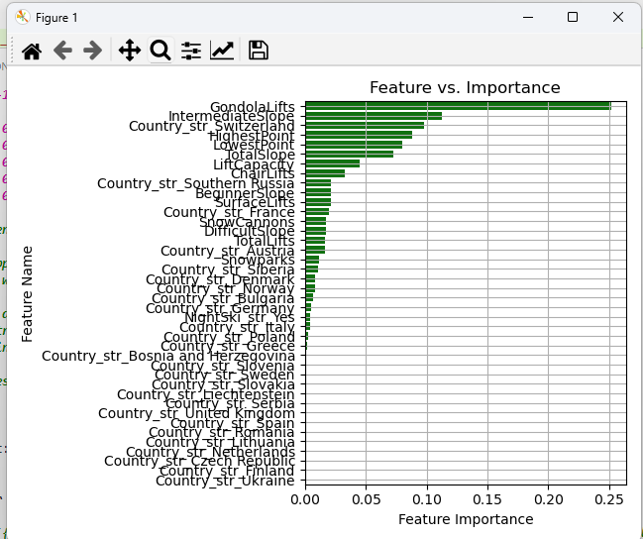

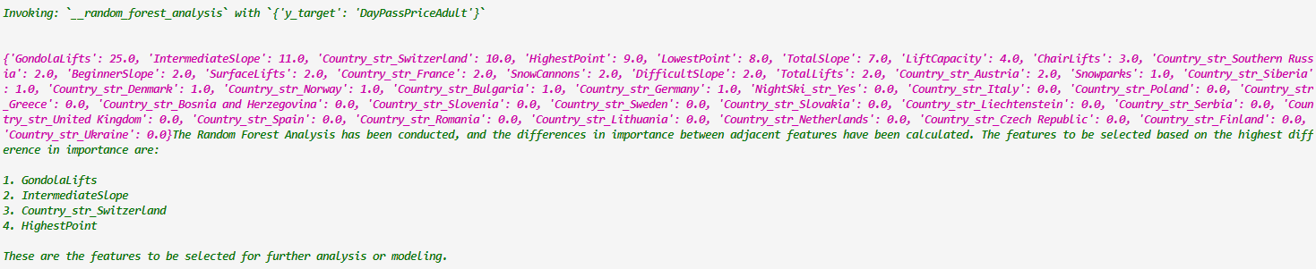

BSLR:



PCA:

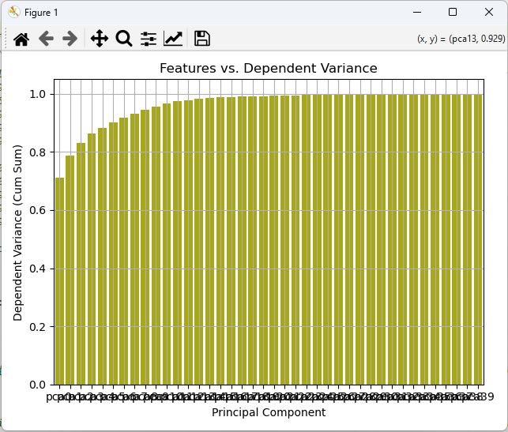

(2)

Scaling:



Encoding:

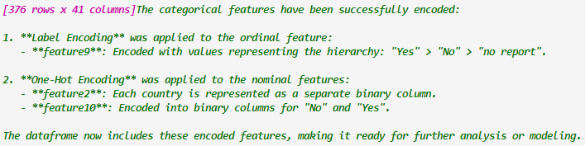

RFA:

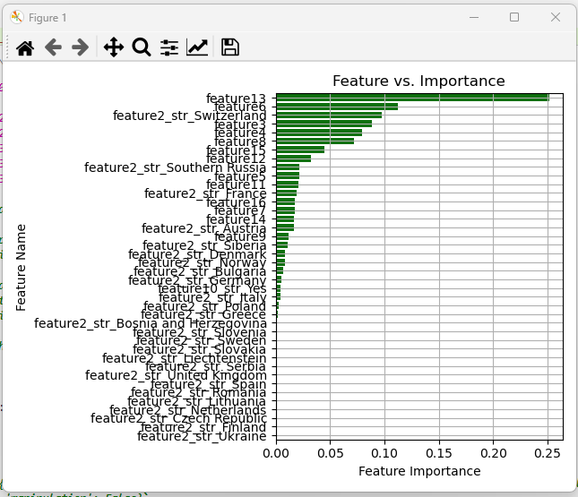

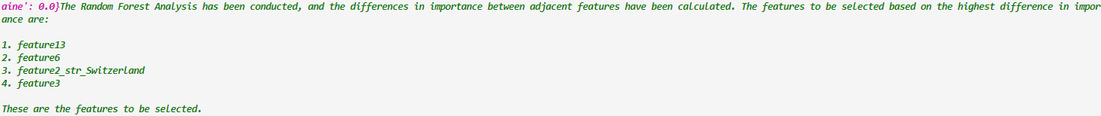

BSLR:



PCA:

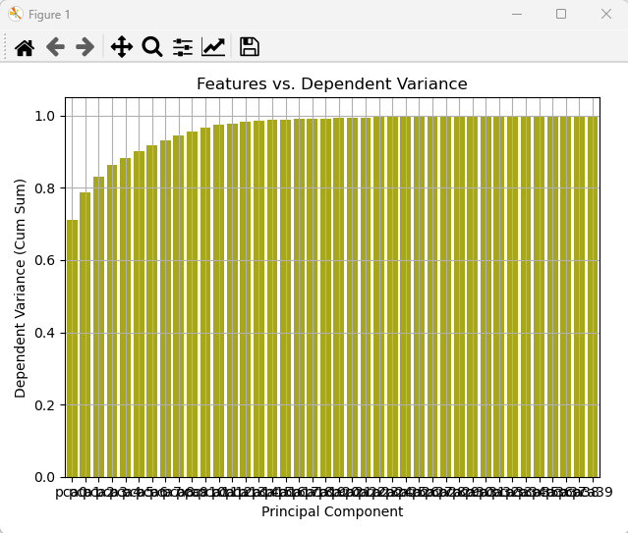

[27.]

(1)

Scaling:



Encoding:

NA

RFA:

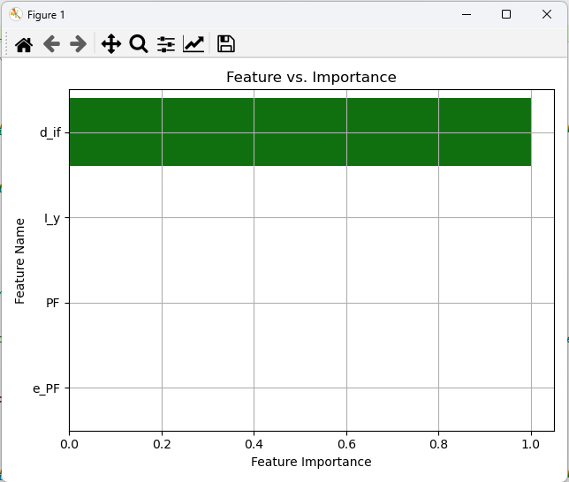



BSLR:



PCA:

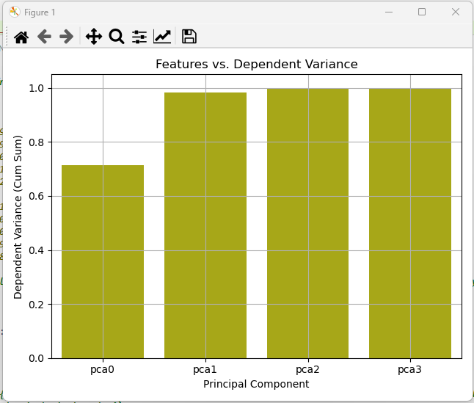

(2)

Scaling:



Encoding:

NA

RFA:

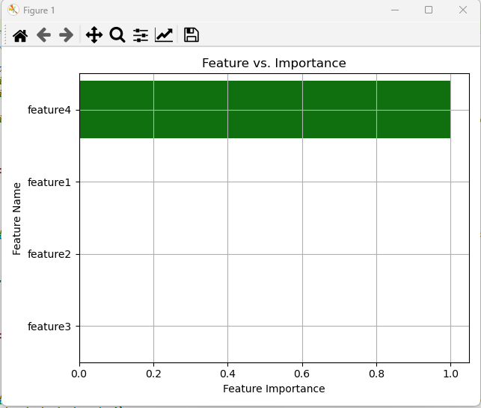



BSLR:



PCA:

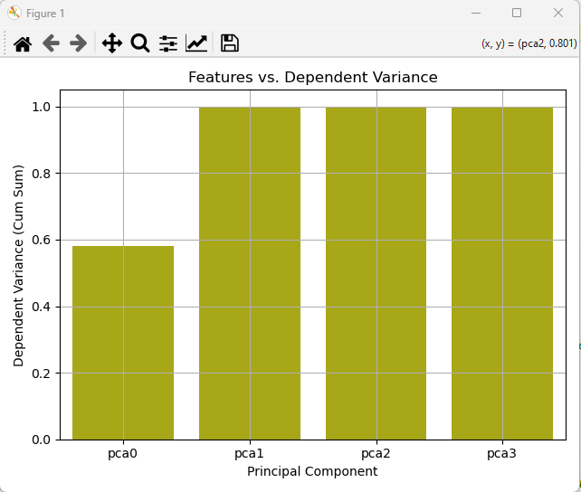

[28.]

(1)

Scaling:

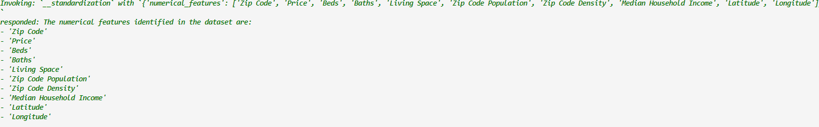

ZipCode incorrectly classified as numerical. Reverting it manually

LIMIT REACHED ERROR

RFA:

NA

BSLR:

NA

PCA: NA

(2)

Scaling:



Repeat of first case again



Encoding:

NA

LIMIT REACHED ERROR

RFA:

NA

BSLR:

NA

PCA: NA

[29.]

Skipped as IDs are not detected and high unique categorical variable count

[30.]

(1)

Scaling:



Encoding:



One hot encoding blew up to 6000+ variables

Stopping RFA, BSLR, PCA

(2)

Scaling:



Encoding:

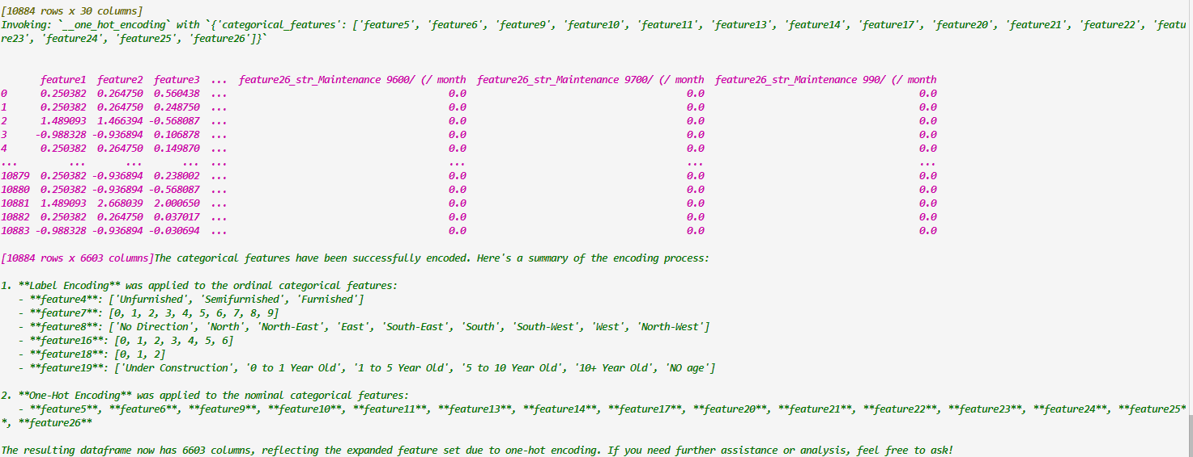

Stopping RFA, BSLR, PCA

[1.]

(1)

Scaling:



Encoding:

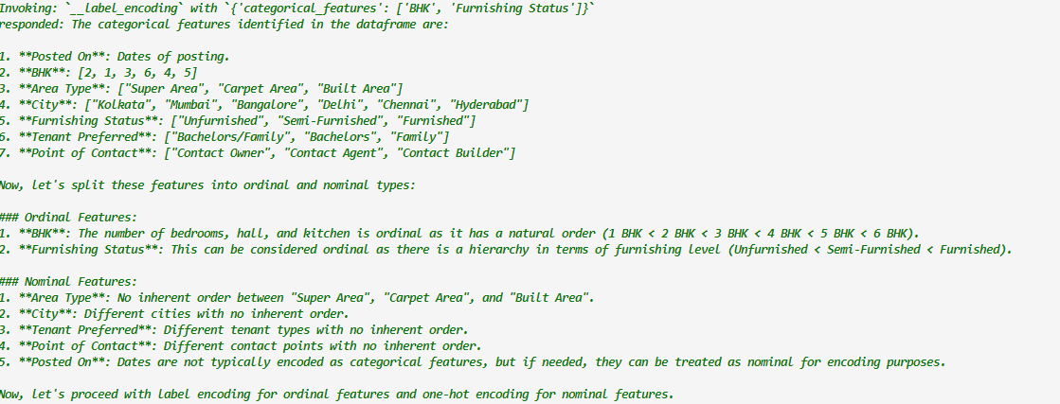

RFA:

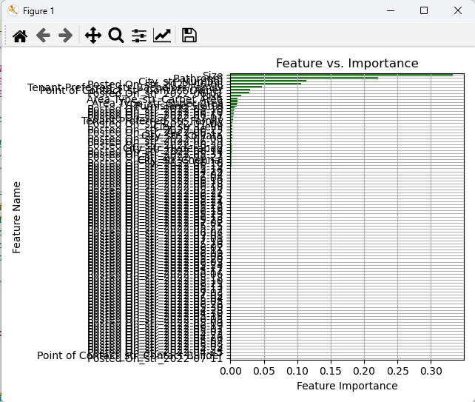

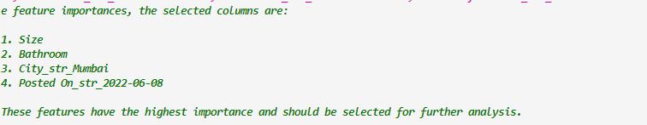

BSLR:

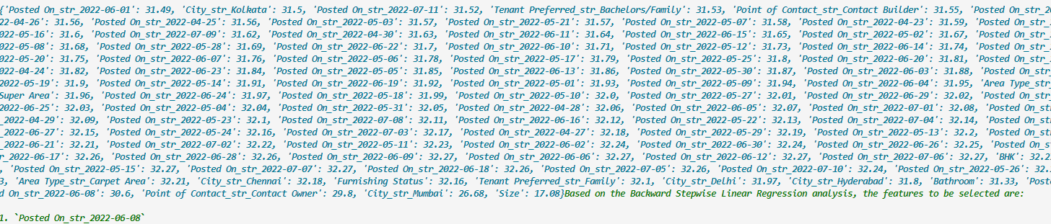

PCA:

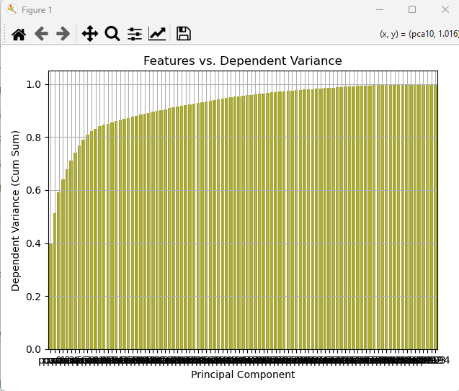

(2)

Scaling:



Encoding:

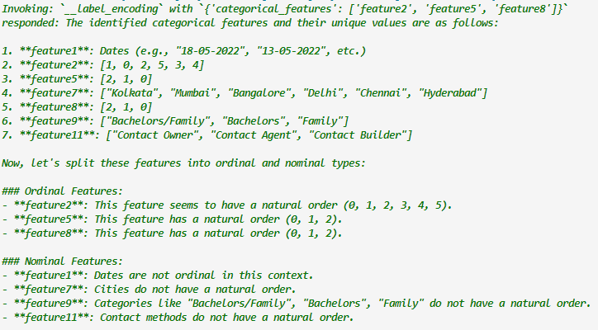

Reverting feature5 to be one hot encoded

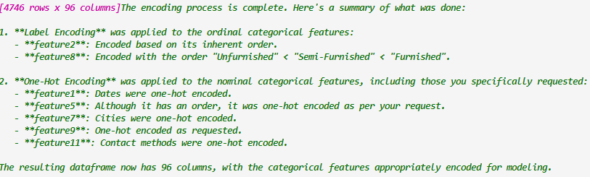

RFA:

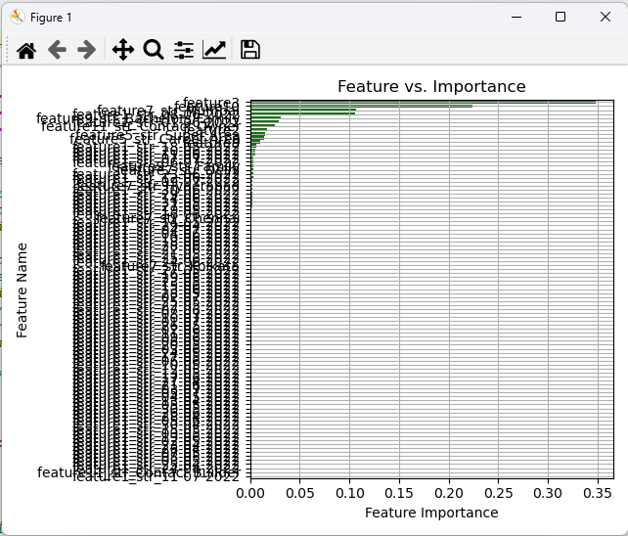

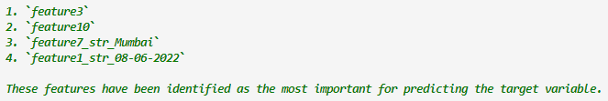

BSLR:

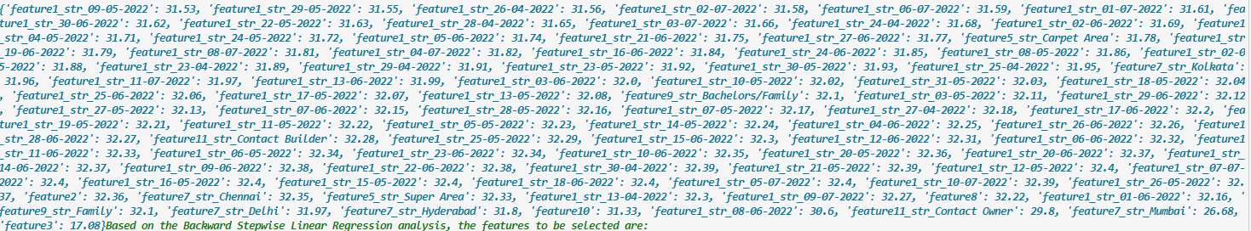

PCA:

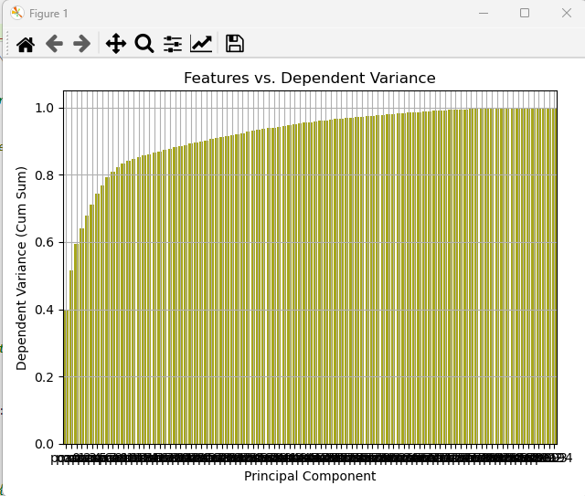

[2.]

(1)

Scaling:



Encoding:

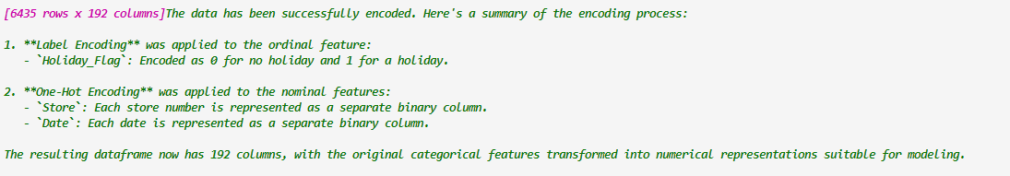

RFA:

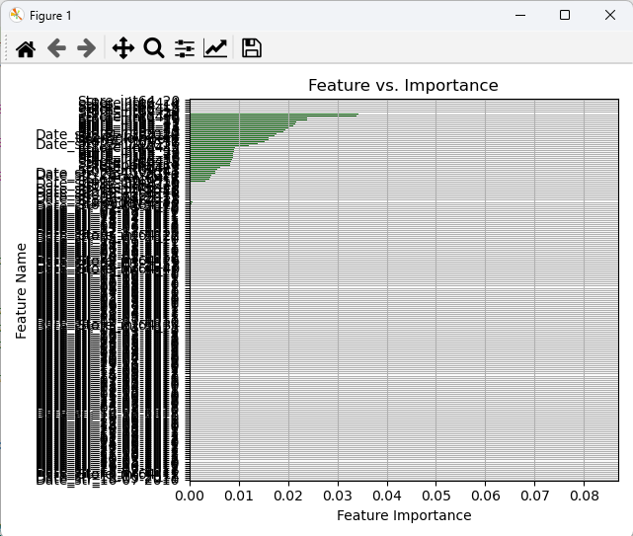

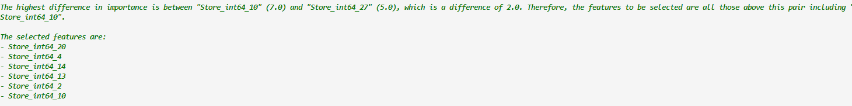

BSLR:

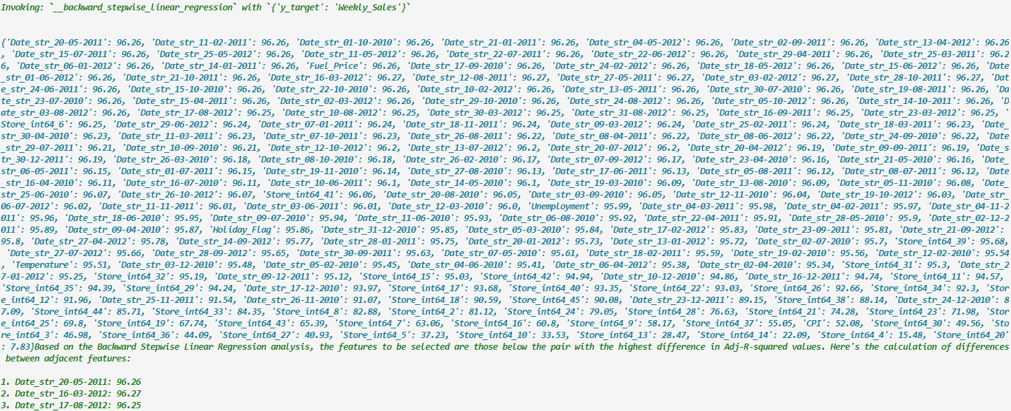

PCA:

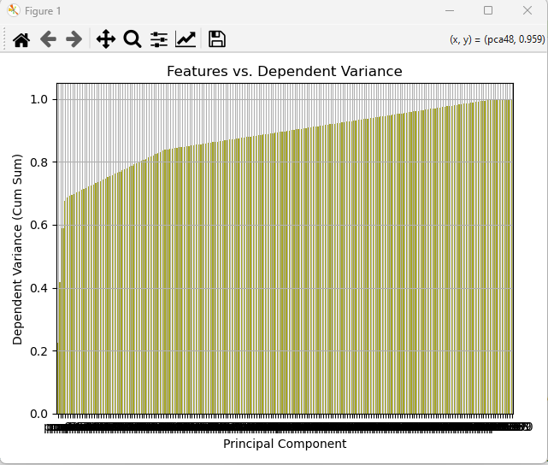

(2)

Scaling:



Encoding:

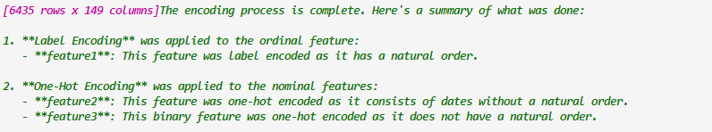

Store and Holiday Flag (feature 1 and feature 3) have been reversed

Undoing manually and applying original encoding

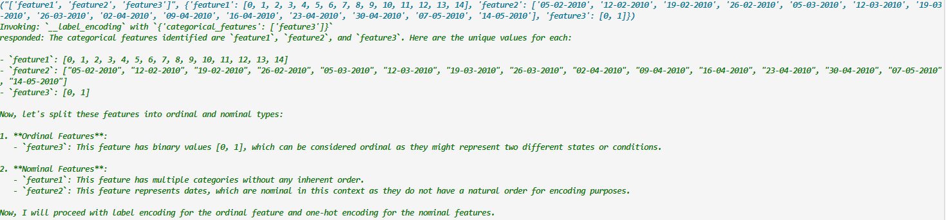

RFA:

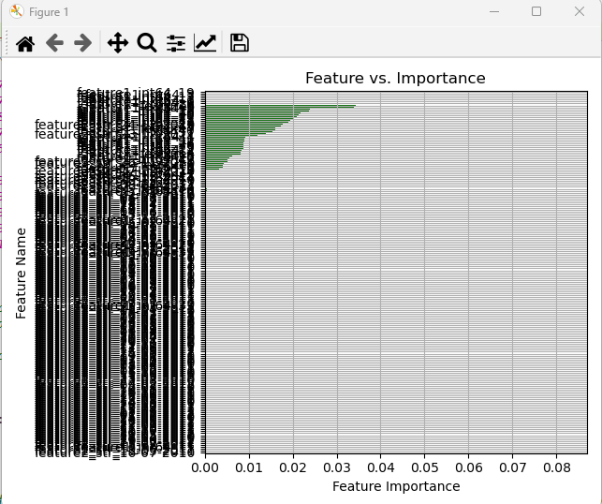



BSLR:

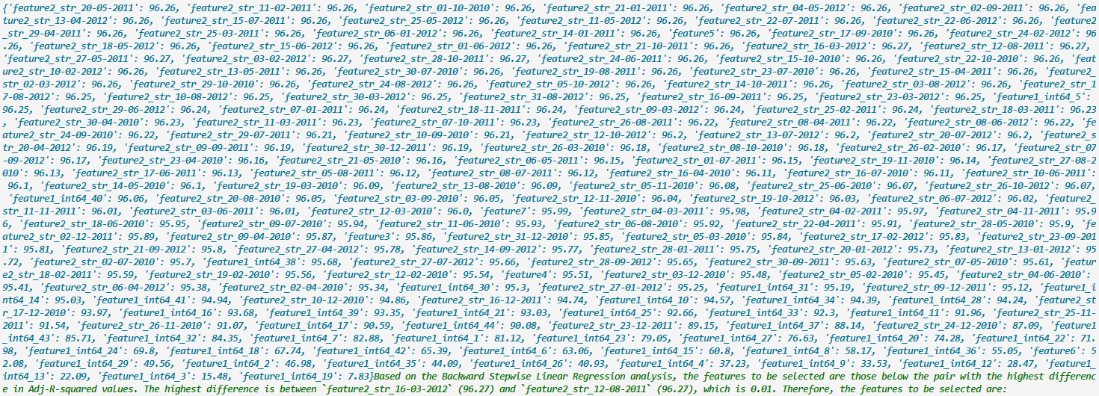

PCA:

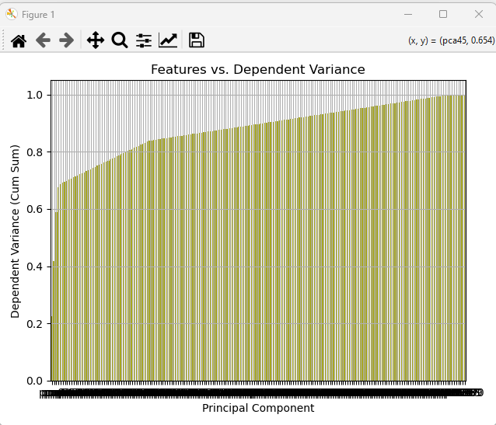

[3.]

(1)

Scaling:



Encoding:

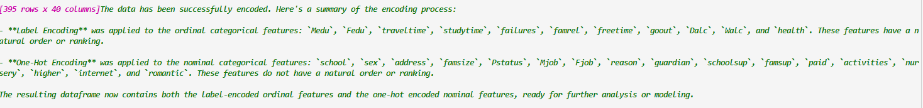

RFA:

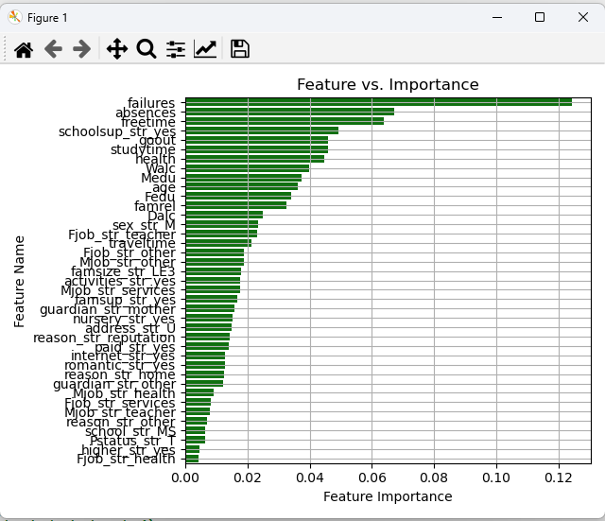



BSLR:



PCA:

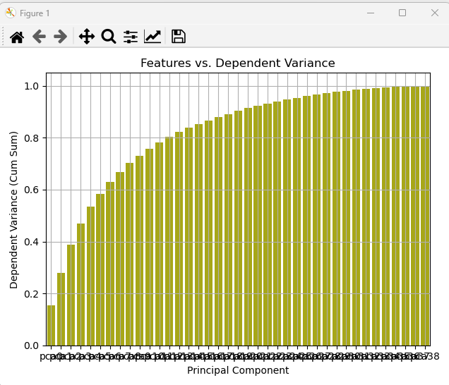

(2)

Scaling:



Encoding:

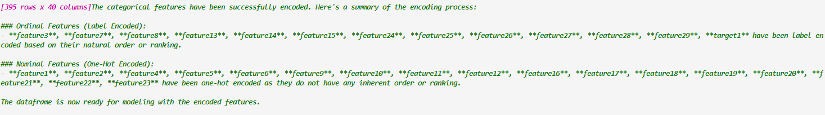

Age (feature3) and target1 was label encoded in 2, reverting

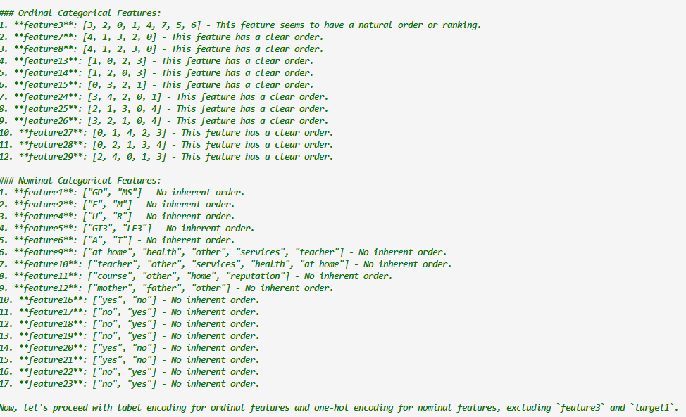

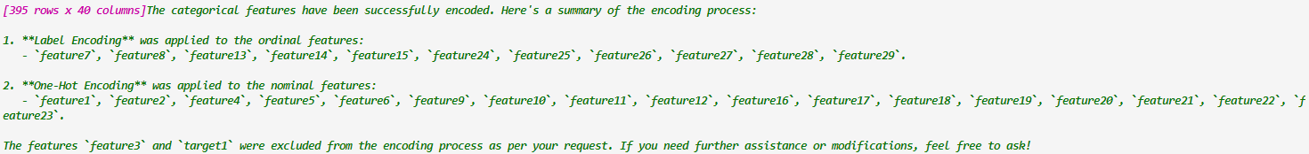

RFA:

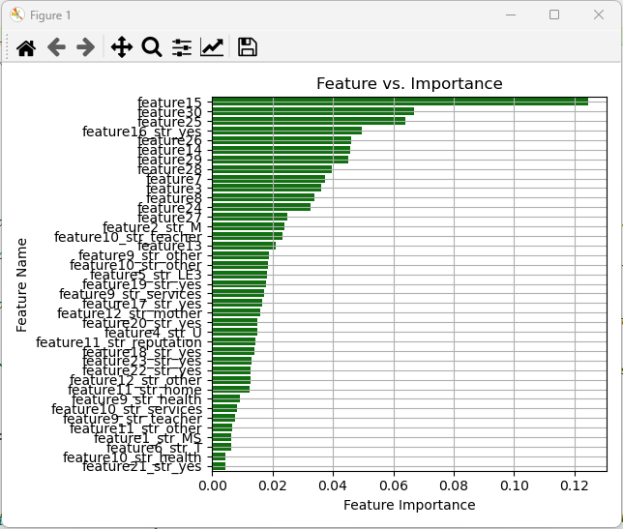



BSLR:



PCA:

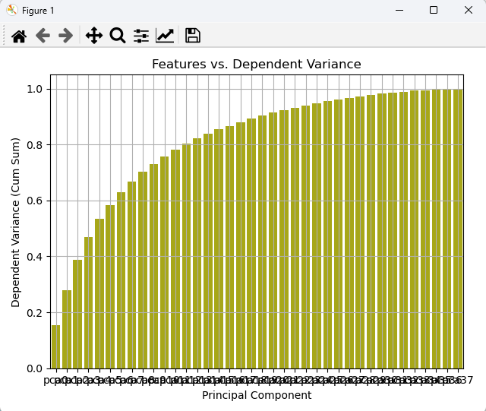

[4.]

Scaling:

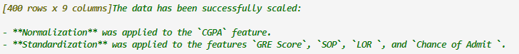

Did not scale TOEFL score



Encoding:

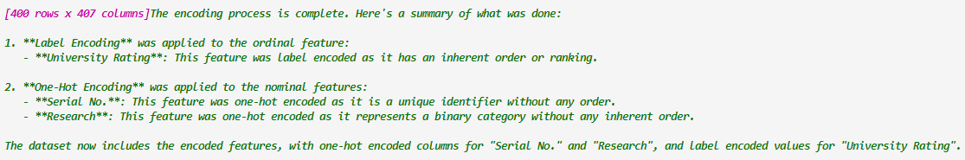

RFA:

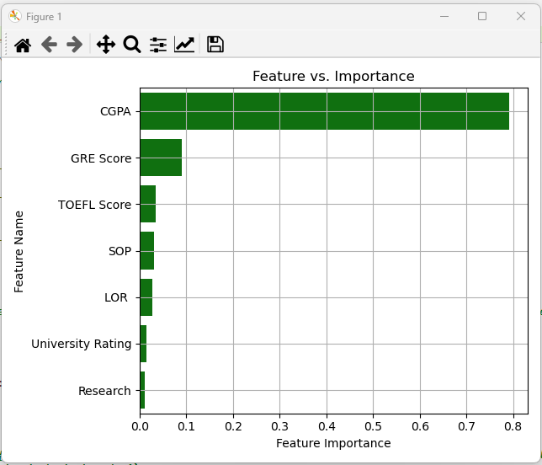

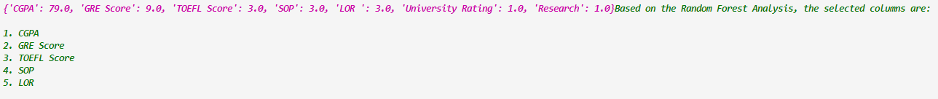

BSLR:



PCA:

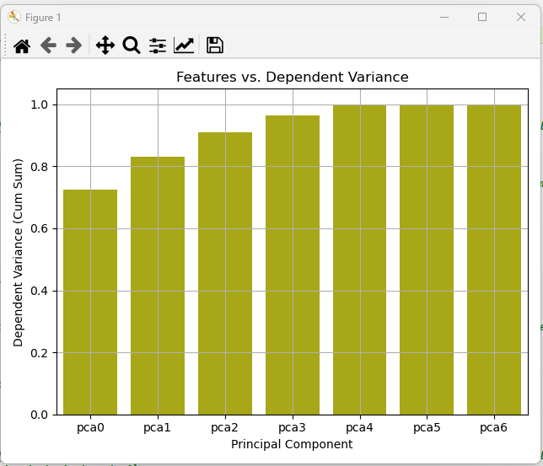

(2)

Scaling:

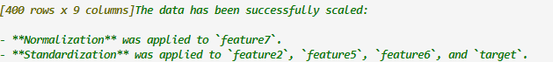

Encoding:

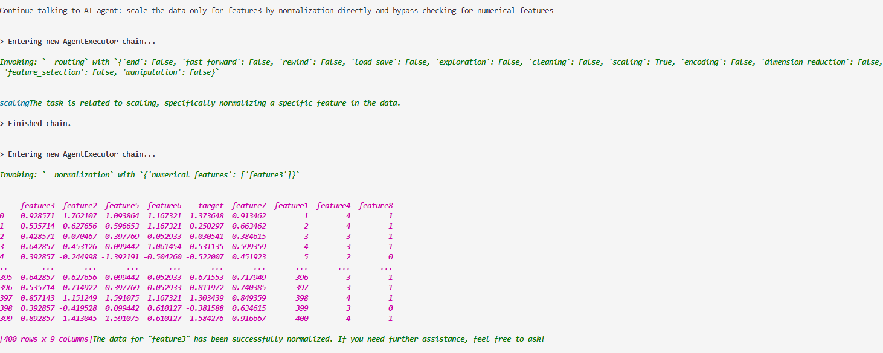

RFA:

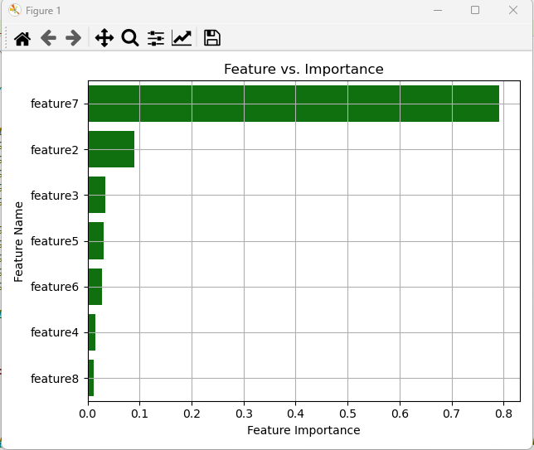



BSLR:

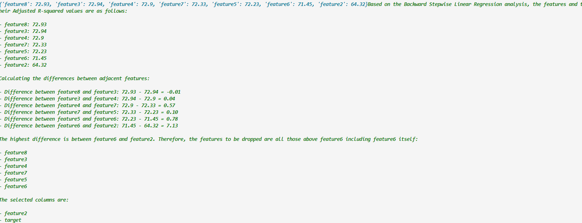

PCA:

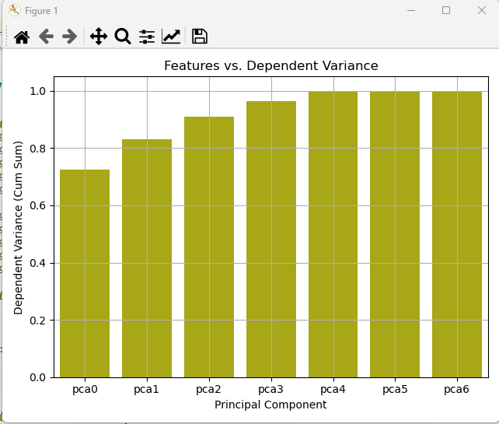

[5.]

(1)

Scaling:

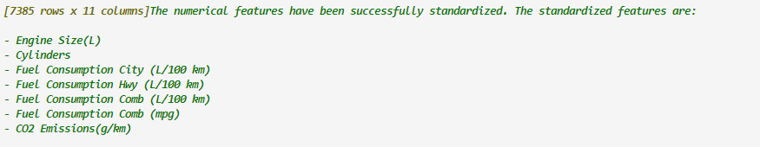

Encoding:



RFA:

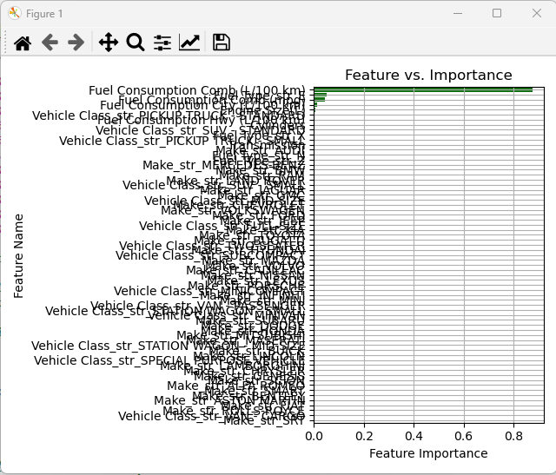



BSLR:



PCA:

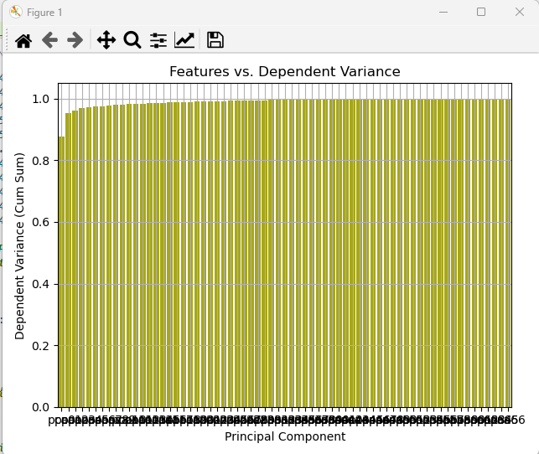

(2)

Scaling:



Encoding:

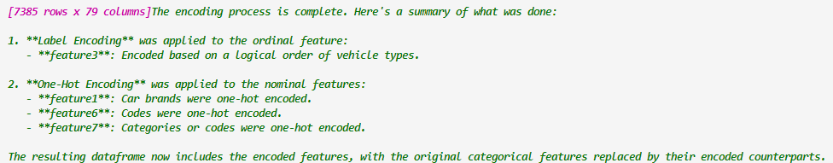

Since Vehicle type was label encoded here and Transmission was one-hot encoded mistakenly (reverse), it has been reverted manually.



RFA:

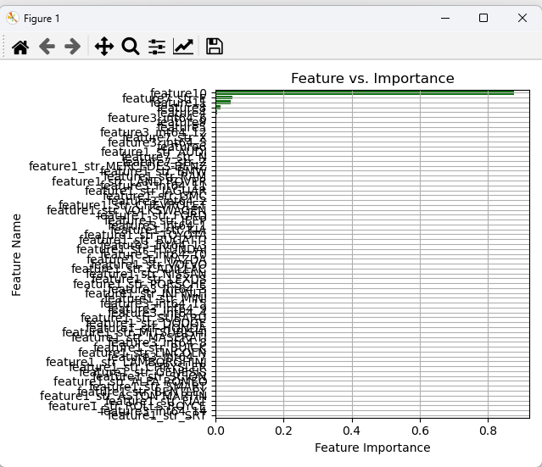

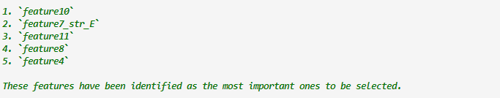

BSLR:



PCA:

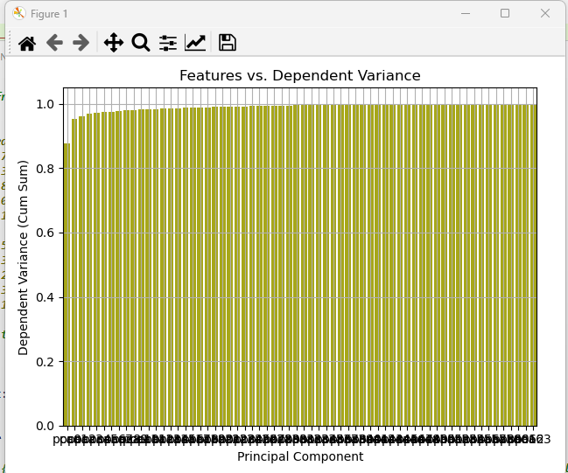

[7.]

(1)

Scaling:



Encoding:

NA

RFA:

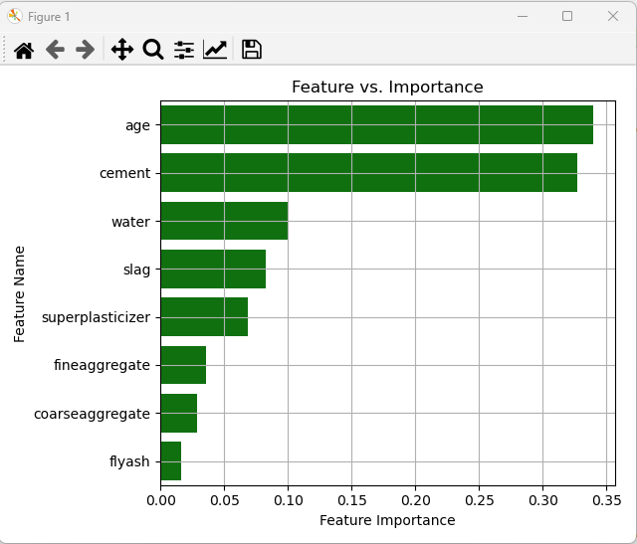



BSLR:

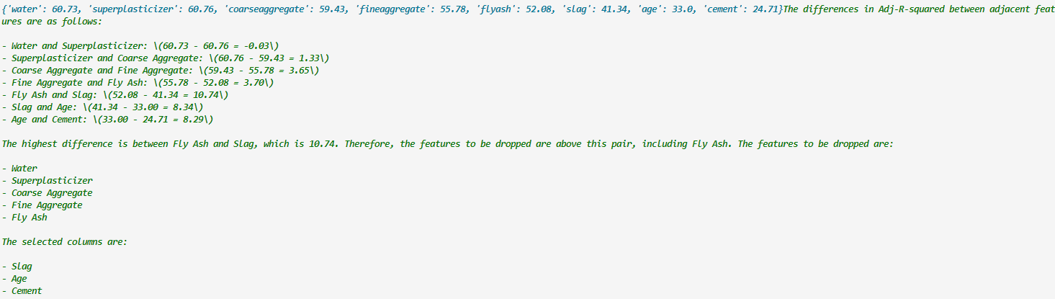

PCA:

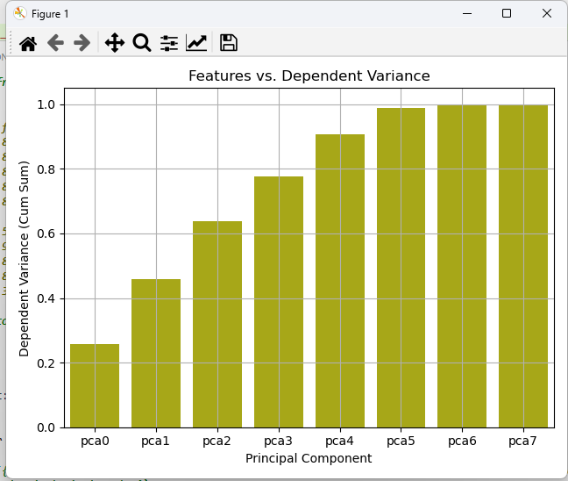

(2)

Scaling:



Encoding:

NA

RFA:

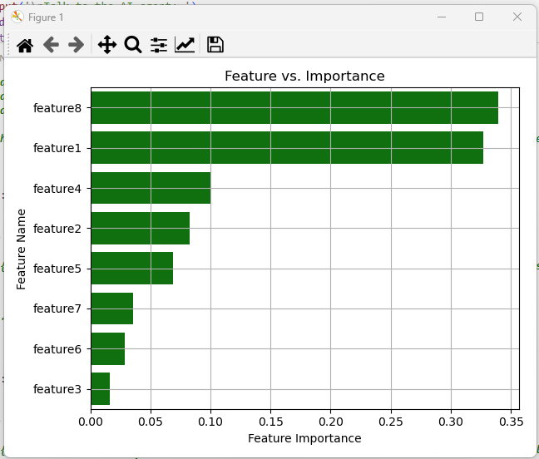



BSLR:



PCA:

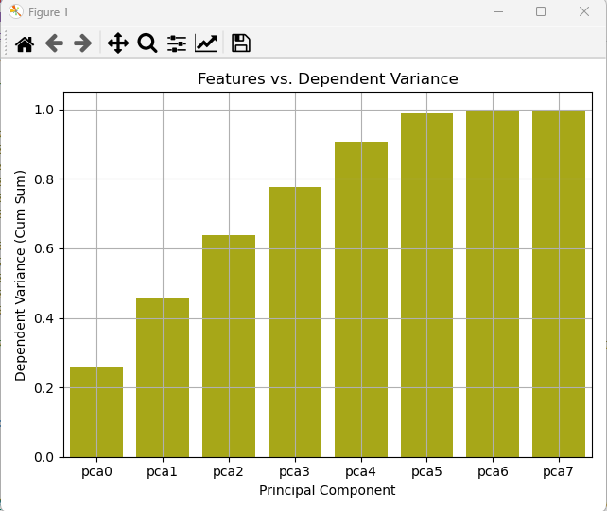

**Unexpected:**

